

Git & GitHub

Date: APR 21, 2023

Table of Contents

1. Git 1

1.1 FEATURES OF GIT 1

1.2 TYPES OF VERSION CONTROL 2

1.3 GIT WORKFLOW 2

3. GIT INSTALLATION ON WINDOWS 4

4 GITHUB AUTHENTICATION 9

5 git operations and commands 12

5.1 SETUP AND CONFIG 12

5.2 GETTING AND SETTING PROJECTS 16

5.3 BASIC SNAPSHOTTING 20

5.4 BRANCHING AND MERGING 26

5.5 SHARING AND UPDATING PROJECTS 41

5.6 INSPECTION AND COMPARISION 45

5.7 PATCHING 47

5.8 OTHER COMMANDS IN GIT BASH 53

6. GITHUB 55

7. FORK IN GITHUB 56

8. WEBHOOKS IN GITHUB 60

9. Document Revision History 62

1. Git

This **Git** is an **open-source distributed version control system**. It is designed to handle minor to major projects with high speed and efficiency. It allows us to achieve collaboration.

* 1. FEATURES OF GIT

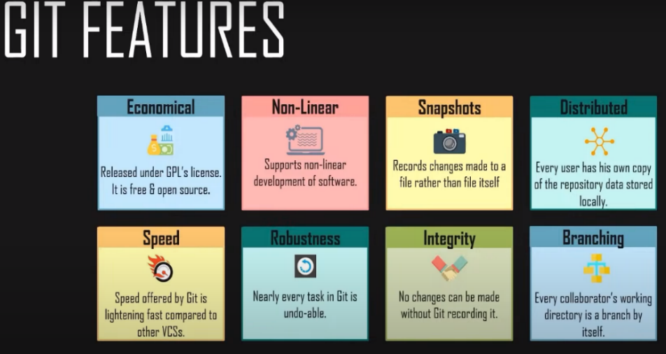

* Economical
* Non-Linear
* Snapshots
* Distributed
* Speed
* Robustness
* Integrity
* Branching

1.2 TYPES OF VERSION CONTROL

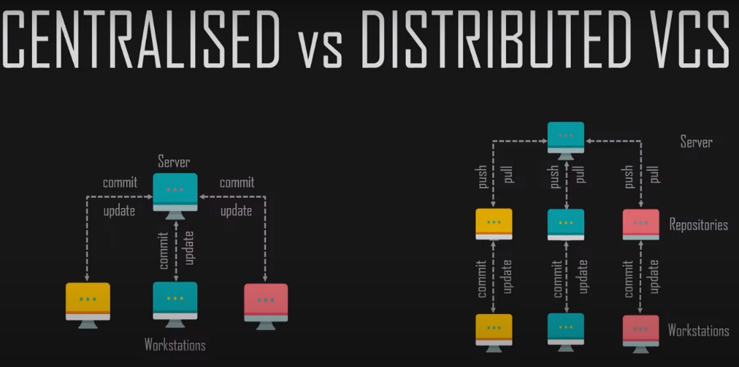

**Centralized:** Centralized version control systems — such as CVS, Perforce, and SVN — require users to pull the latest version from the server to download a local copy on their machine. Contributors then push commits to the server and resolve any merge conflicts on the main repository.

**Distributed:** A distributed version control system (DVCS) brings a local copy of the complete repository to every team member's computer, so they can commit, branch, and merge locally. The server doesn't have to store a physical file for each branch — it just needs the differences between each commit.

1.3 GIT WORKFLOW

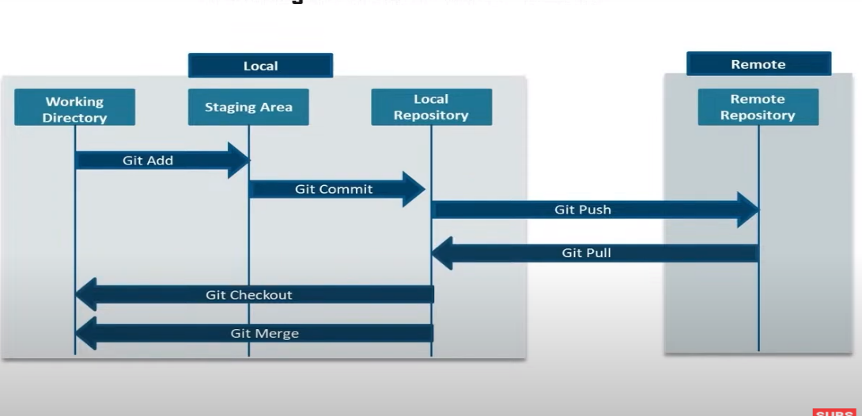

The Git workflow is divided into three states:

* Working directory - Modify files in your working directory
* Staging area (Index) - Stage the files and add snapshots of them to your staging area
* Git directory (Repository) - Perform a commit that stores the snapshots permanently to your Git directory. Checkout any existing version, make changes, stage them and commit.

2. GIT VERSUS GITHUB

**Git:** Git is a distributed version control system for tracking changes in source code during software development. It is designed for coordinating work among programmers, but it can be used to track changes in any set of files. Its goals include speed, data integrity, and support for distributed, non-linear workflows.

**GitHub:** GitHub is a web-based Git repository hosting service, which offers all the distributed revision control and source code management (SCM) functionality of Git as well as adding its own features.

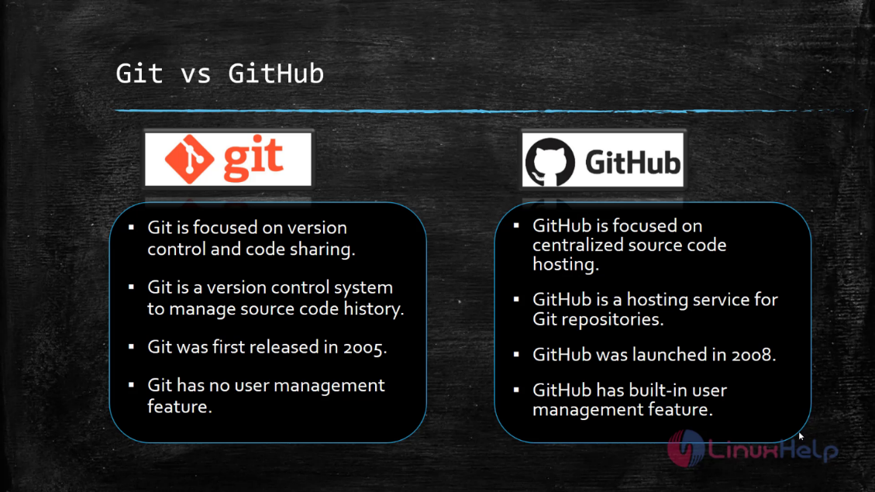

3. GIT INSTALLATION ON WINDOWS

Let us now look at the various steps in the Git installation on Windows.

**Step1**

To download the Git installer, visit the Git's official site and go to download page. The link for the download page is <https://git-scm.com/downloads>. The page looks like as

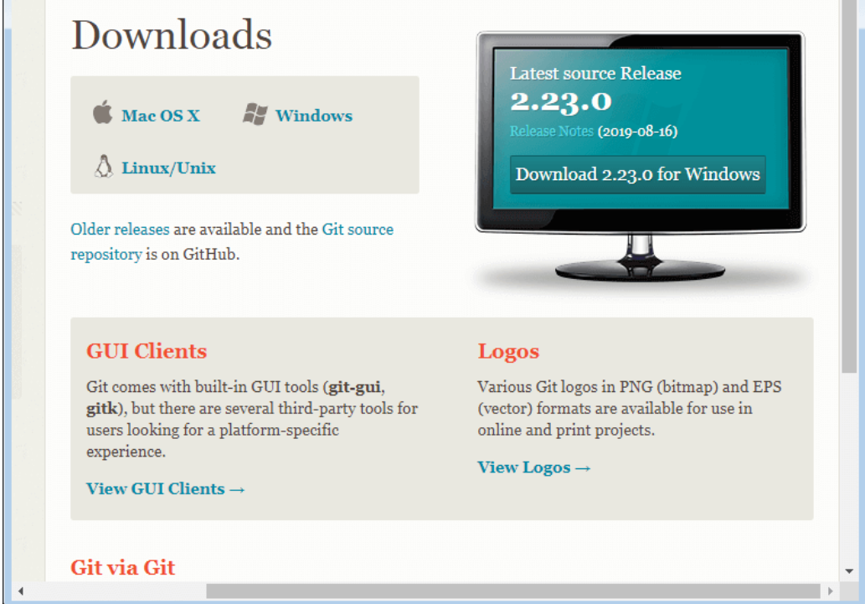

**Click on the Operating system (Windows) where you want to install Git. Download the latest version of git Installer File.**

**Step2**

Click on the downloaded installer file and select **yes** to continue. After the selecting **yes** the installation begins, and the screen will look like as

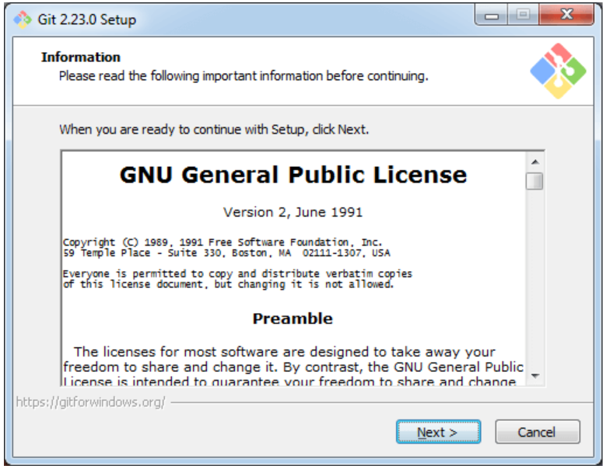

Click on **next** to continue.

**Step3**

Default components are automatically selected in this step. You can also choose your required part.

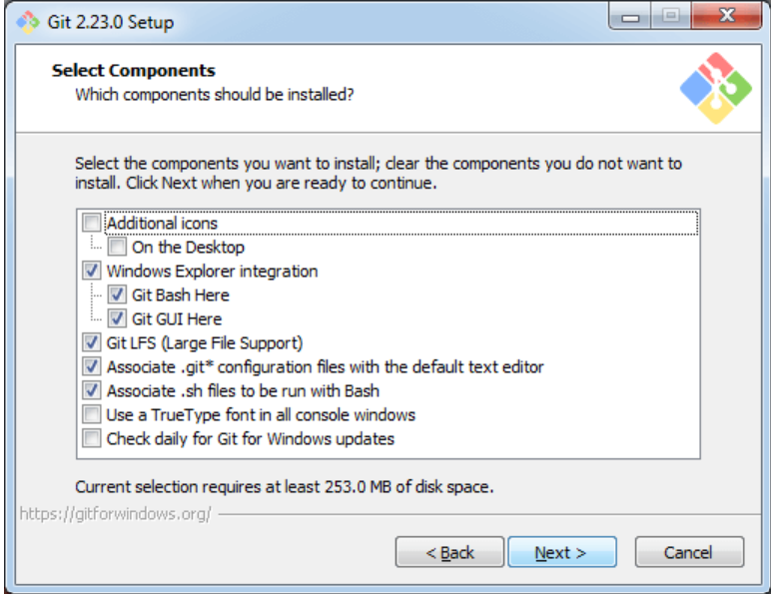

Click next to continue.

**Step4**

The default Git command-line options are selected automatically. You can choose your preferred choice. Click **next** to continue.

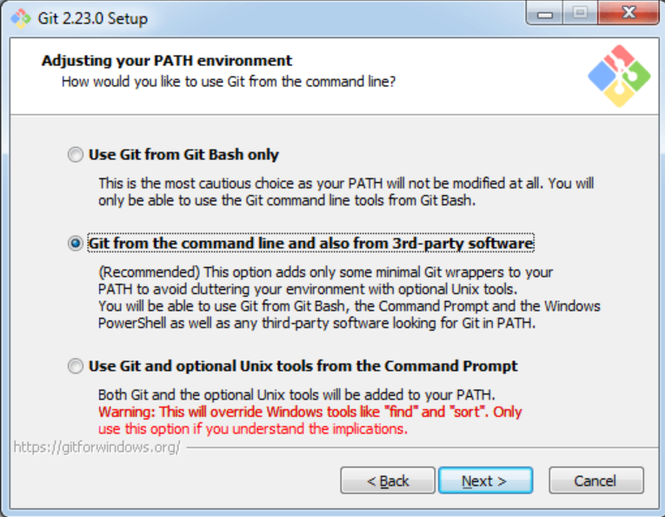

**Step5**

The default transport backend options are selected in this step. Click **next** to continue.

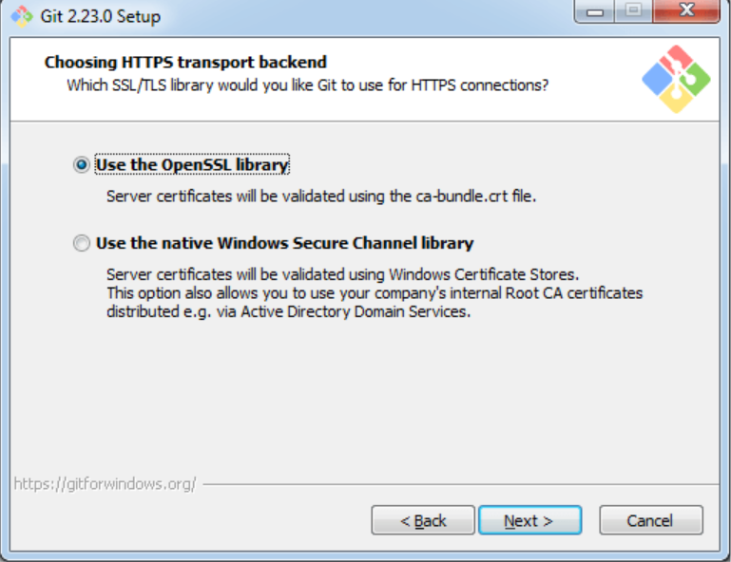

**Step6**

Select your required line ending option and click next to continue.

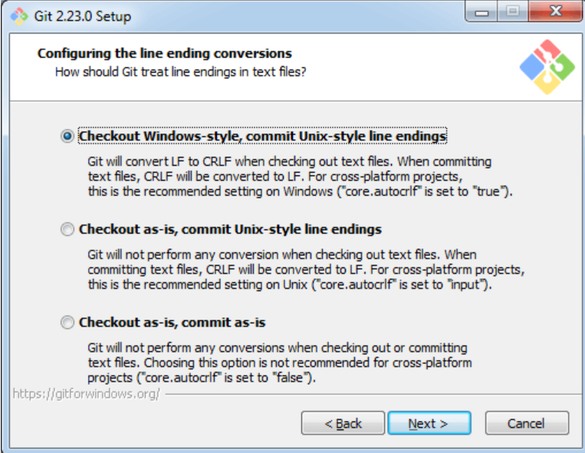

**Step7**

Select preferred terminal emulator clicks on the **next** to continue.

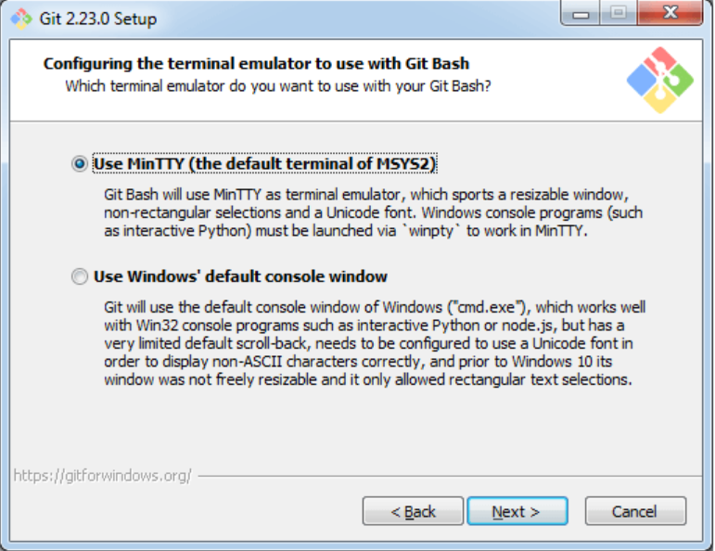

**Step8**

This is the last step that provides some extra features like system caching, credential management and symbolic link. Select the required features and click on the **next** option.

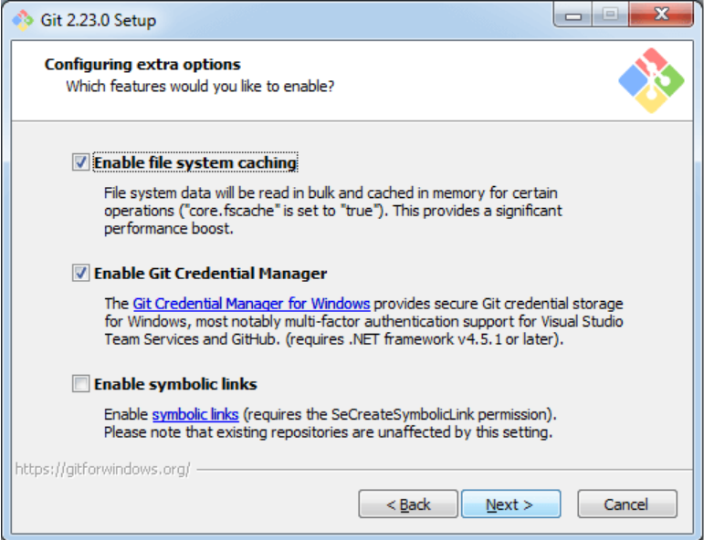

**Step9**

The files are being extracted in this step.

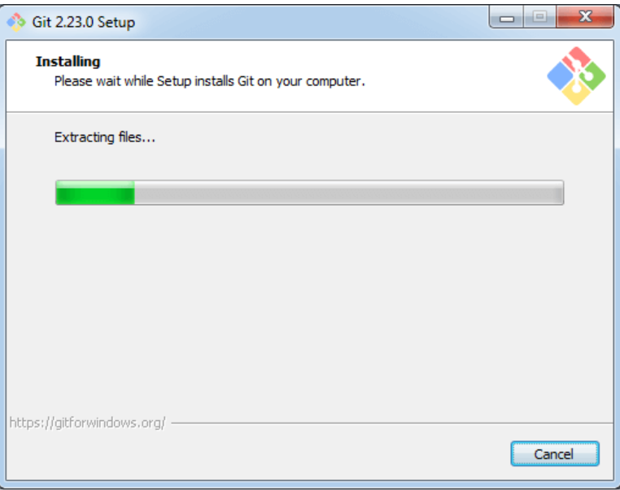

To check git version in command prompt use command:

**git –version**

4. GITHUB AUTHENTICATION

There are two types of authentication process which is commonly used:

* Password authentication
* SSH Key authentication

1. **Password Authentication**: In password authentication the user must provide his username and has to set up a password through which he can authenticate remote repositories. To prevent entering the username and password repeatedly we can set the username and password in the config file. This method prevents repeatedly entering the username and password.

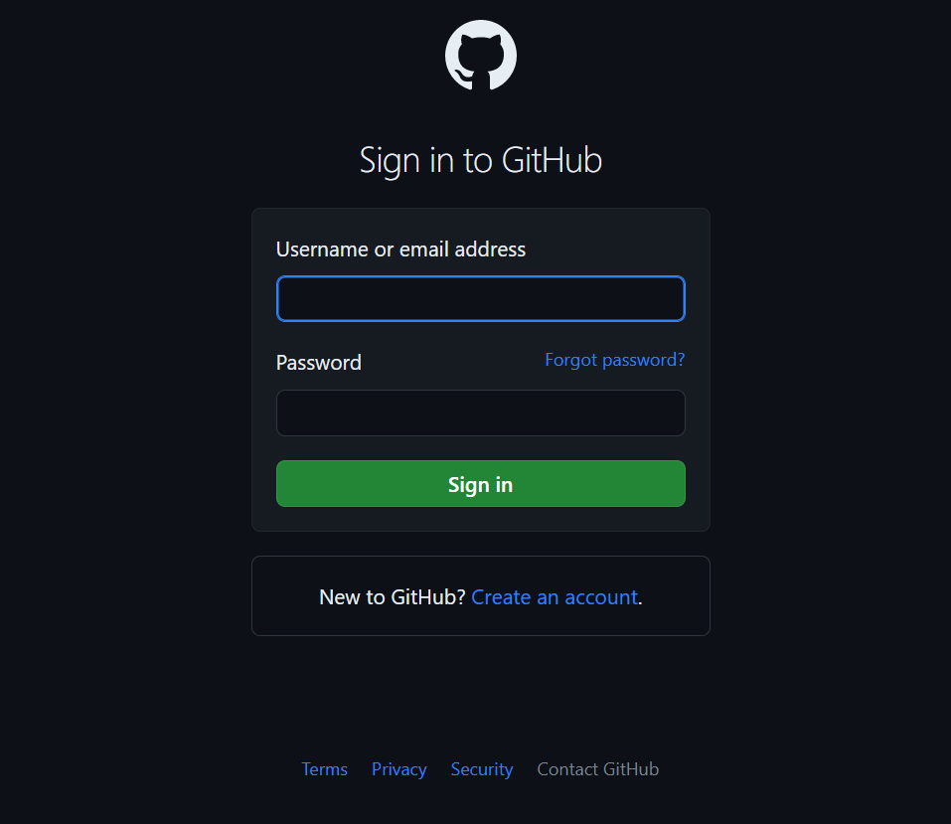

1. **SSH-Key Authentication:** SSH keys are commonly used in git for secure communication between a client and a server. To use SSH Authentication you should be logged into your GitHub account using username and password. Once logged in you need to enable SSH connection to Git Hub. This can be done using Git bash. The steps to achieve above SSH connection are mentioned below.

**Open git Bash Terminal**

* **To generate SSH key for git:** ssh-keygen -t rsa -b 4096 -c “[example@gmail.com](mailto:example@gmail.com)”

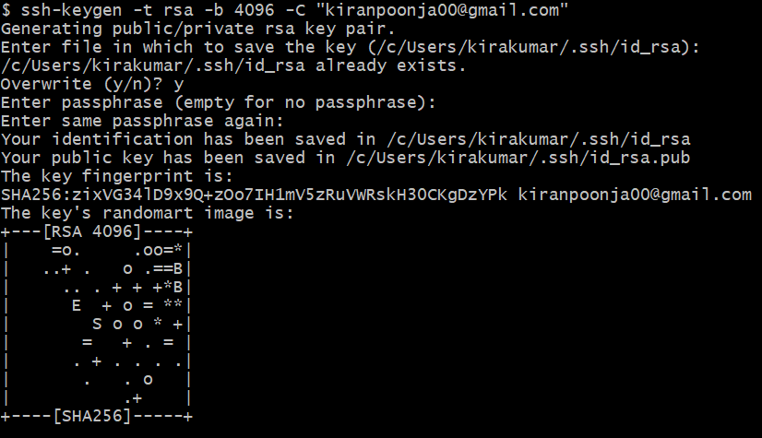

* **Specify location of the file.**
* **Enter paraphrase.**
* **Start SSH-agent:** eval $(ssh-agent -s)

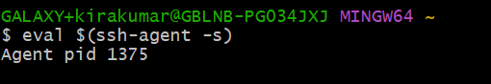

* **Add the new ssh key to the ssh agent:** ssh-add ~/.ssh/id_rsa



* **Open ssh-key:** cat ~/.ssh/id_rsa.pub



* **Copy the key and paste it in your GitHub website.**

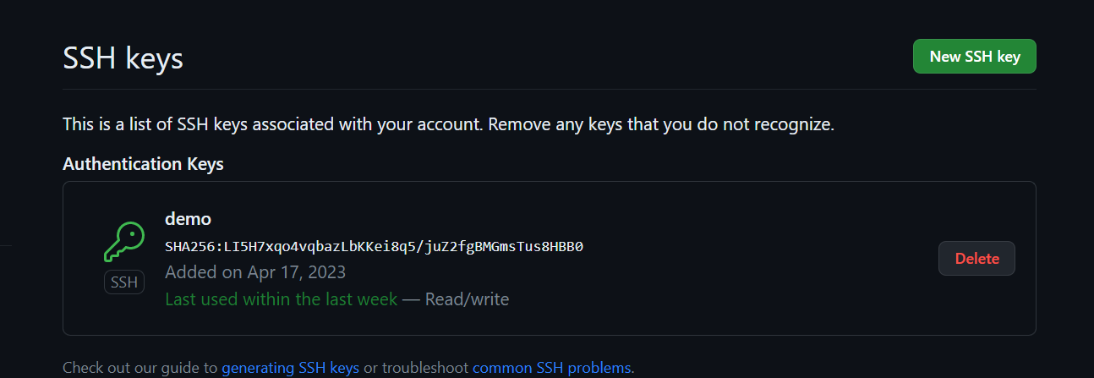

* **Cloning repo using ssh-key.**

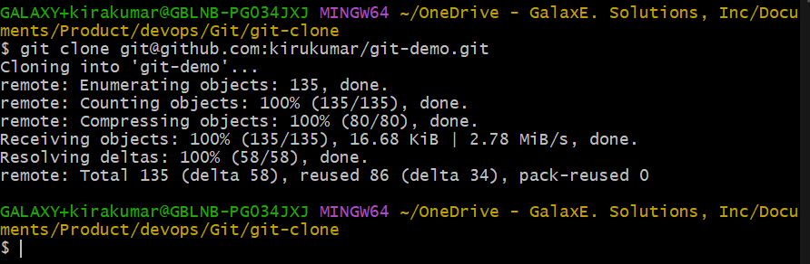

5. git operations and commands

5.1 SETUP AND CONFIG

* **git**: Git is a fast, scalable, distributed revision control system with an unusually rich command set that provides both high-level operations and full access to internals.

**Options**

**-v or --version:** Prints the Git suite version that the git program came from.

Syntax: git -v or git --version

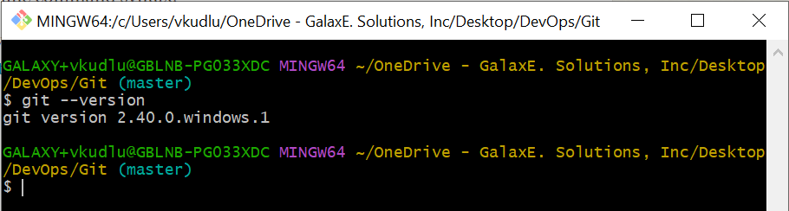

**-h or --help:** Prints the synopsis and a list of the most used commands.

Syntax: git -h or git –help

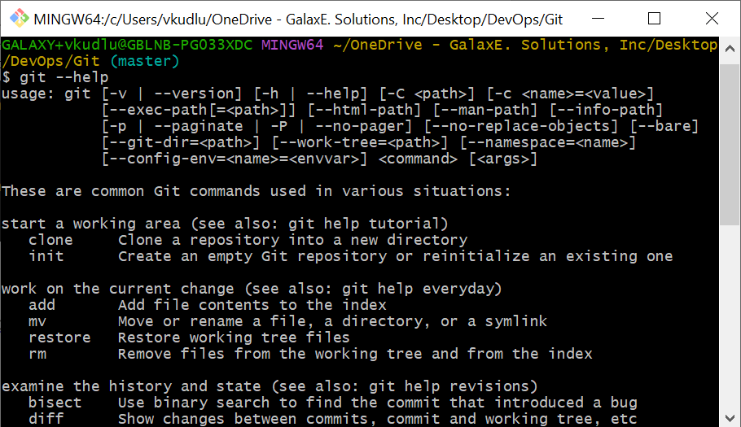

**--man-path:** Print the manpath for the man pages for this version of Git and exit. It will display the path for the git manual pages.

Syntax: git --man-path

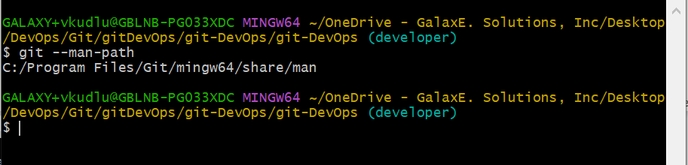

You can use man pager to view the manual pages for specific git commands.

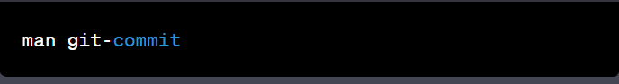

* **git config:** This command in Git is used to set or get configuration variables that controls various aspects of Git’s behaviour.

Syntax: git config --global user.email “email” or git config user.email “email”

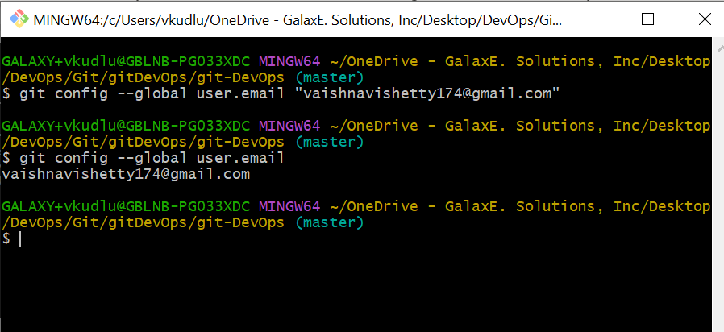

**Options**

**--list:** List all variables set in config file, along with their values.

Syntax: git config --list

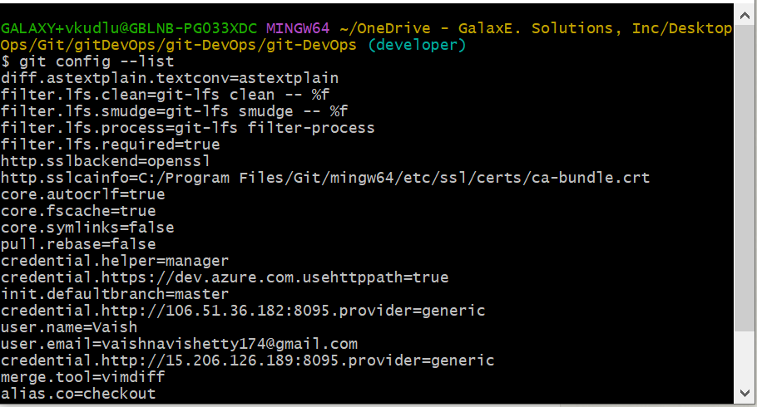

**-e or --edit:** Opens an editor to modify the specified config file; either --system, --global, or repository (default).

Syntax**:** git config -e or got config --edit

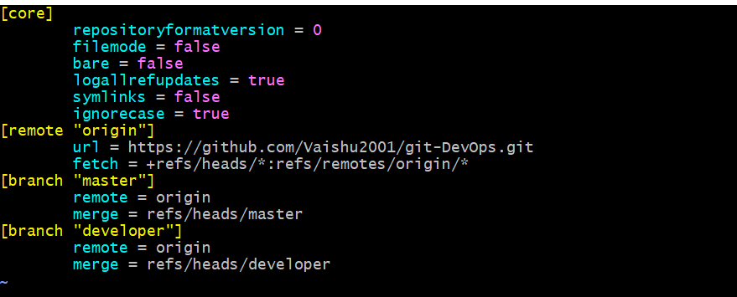

* **git-help**: Displays documentation and help pages for various Git commands and topics.

**Options**

**--all:** Prints all the available commands on the standard output.

Syntax: git help --all

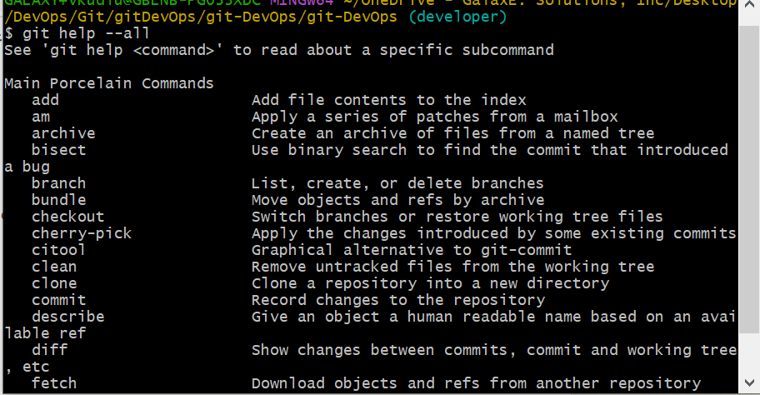

**--config:** List all available configuration variables.

Syntax: git help --config

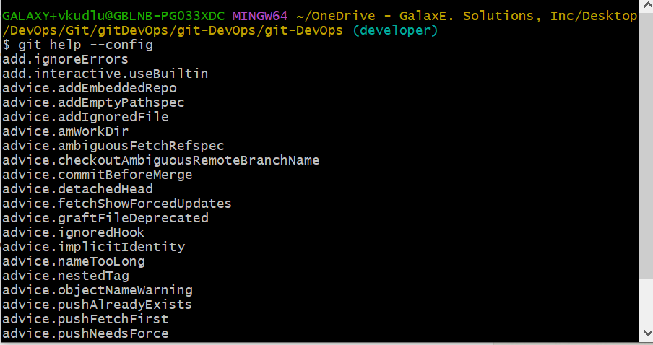

­5.2 GETTING AND SETTING PROJECTS

* **git init:** It creates a new Git repository and will create a new directory with the name of your repository, initialize an empty Git repository in it, and set up the necessary files and directories for the Git to work properly. This command needs to be executed once per repository. If you have already created a Git repository in a directory, running git init will overwrite the existing repository and version history.

Syntax: git init

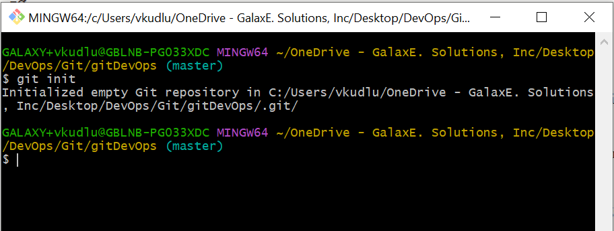

**Options**

**--bare:** The --bare flag creates a repository that doesn't have a working directory, making it impossible to edit files and commit changes in that repository. You would create a bare repository to git push and git pull from, but never directly commit to it.

Syntax: git int --bare

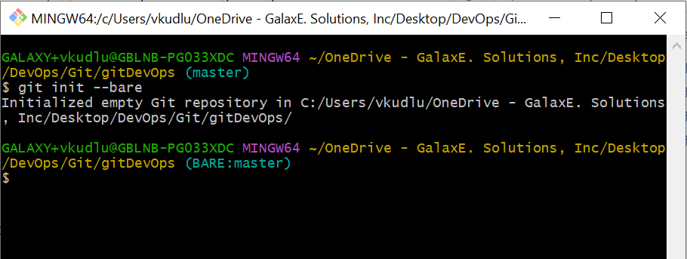

**--quiet:** Only print errors and warning messages; all other output will be suppressed. It will suppress any unnecessary output or messages during the initialization process.

Syntax: git init --quiet

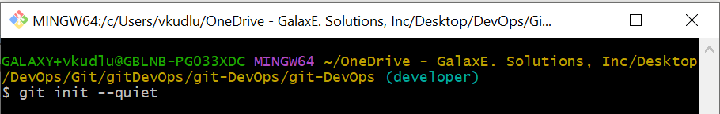

**-b <branch-name>:** The command "git init -b <branch-name>" will initialize a new Git repository with an initial branch specified by the "<branch-name>" argument. The "git init" command is used to create a new Git repository. By default, Git initializes the repository with a master branch. However, you can use the "-b" option to specify a different initial branch name.

Syntax: git init -b <branchname>

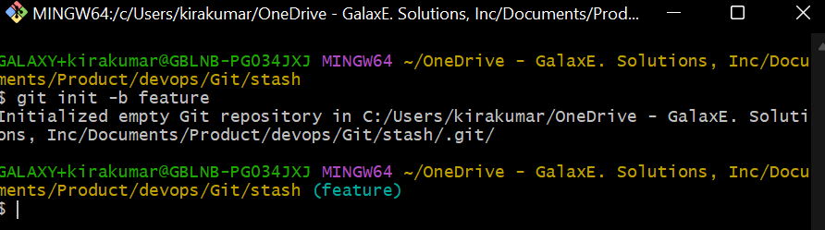

* **git clone:** It is used to target an existing repository and create a copy of it in your local machine.

Syntax: git clone <URL>

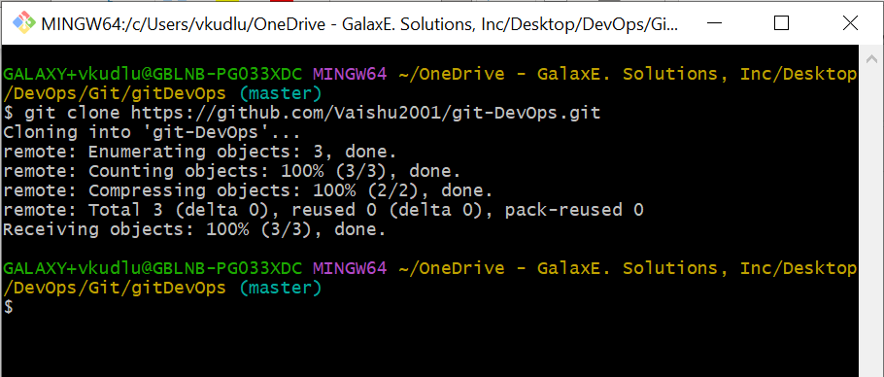

**--local:** The command "git clone --local" is used to create a local copy of a Git repository. When you clone a Git repository, you create a copy of the repository on your local machine. By default, Git will download the repository from a remote location, such as a Git hosting service like GitHub, GitLab, or Bitbucket. However, if the repository is already on your local machine, you can use the "--local" option to clone it without downloading it from a remote location.

Syntax: git clone --local <path of the local repo>

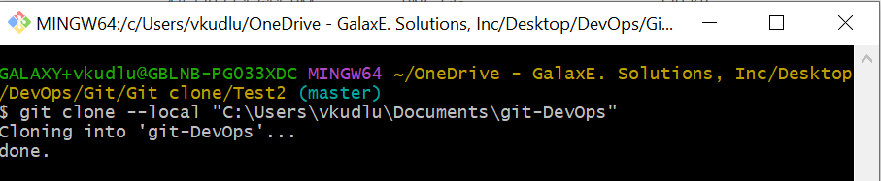

**--mirror:** When you use the "--mirror" option, Git will create a mirror copy of the repository, which means that it will include all the Git metadata, but it will not include a working tree. This can be useful if you want to create a copy of the repository for backup purposes or if you want to create a copy of the repository that is read-only. Note that since the mirror copy is read-only, you will not be able to make any changes directly to it.

Syntax: git clone --mirror <URL>

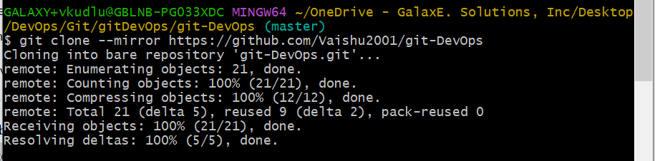

* **git Alias:** This command is used to create custom shorthand for commonly used Git commands or command sequences. This can be useful for simplifying complex or frequently used commands, or for creating your own custom Git workflows.

Syntax: git config --global alias.<alias word> <command>

Ex: git config --global alias.co checkout – Here co is the alias word and checkout is the command.

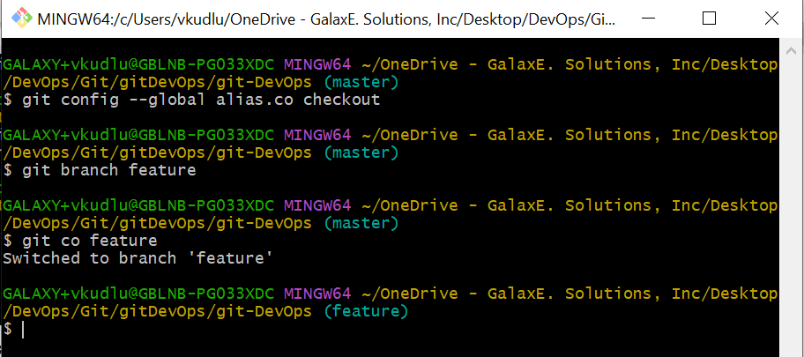

* 1. BASIC SNAPSHOTTING
* **git status:** This command is used to display state of the working area and staging area and will show which all files are modified, newly added since the last commit, and also will show whether they have been staged for the next commit, if after executing git add command.

Syntax: git status

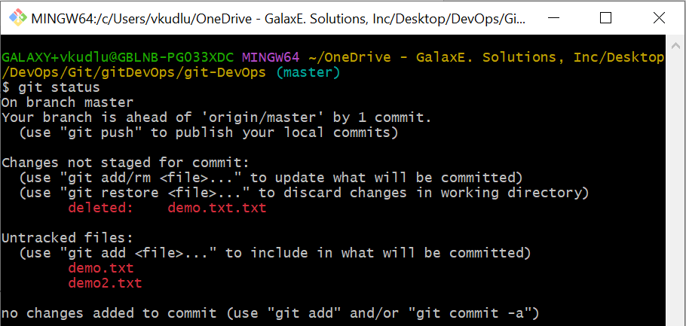

**Alternative way to get the git status**

Syntax: git status -b

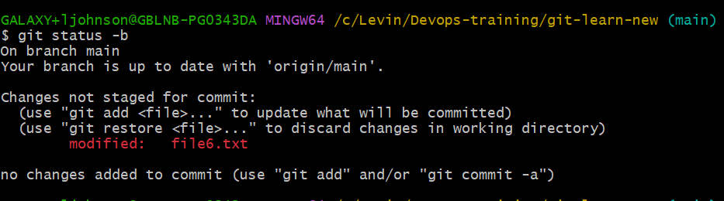

**Options**

**-s or --short:** Shortens the git status command description.

Syntax: git status -s or git status --short



**--show-stash:** It Shows count of the stashed items.

Syntax: git status --show-stash

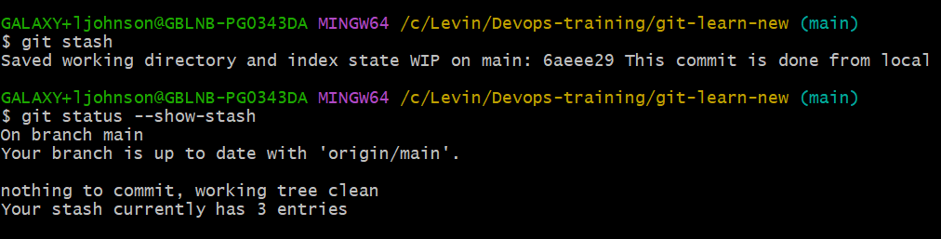

* **git add:** adds the changes from the working directory to the staging area. Staging area is the mid-range area between the workspace and local repository area.

Syntax: git add <filename1> <filename2>

**Options**

**-help:** gives all the options.

Syntax: git add -help

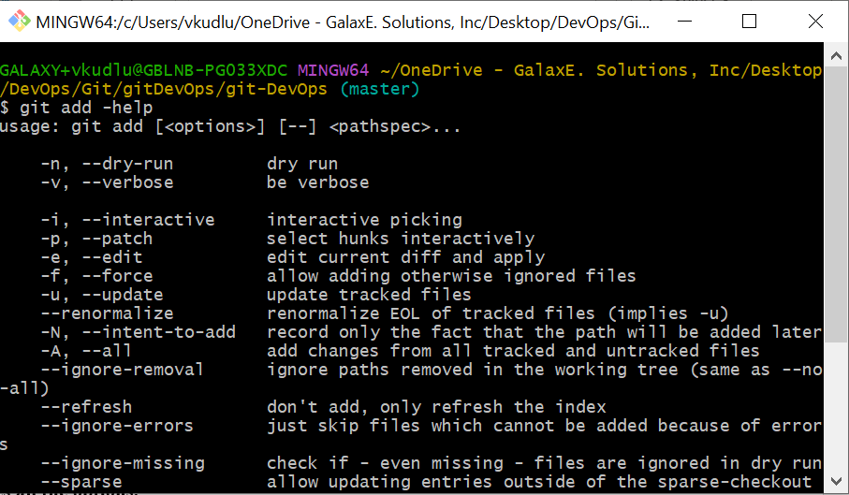

**--all or -A or git add . :** To add all changes irrespective of any file modified into the staging area.

Syntax: git add -A or git add --all

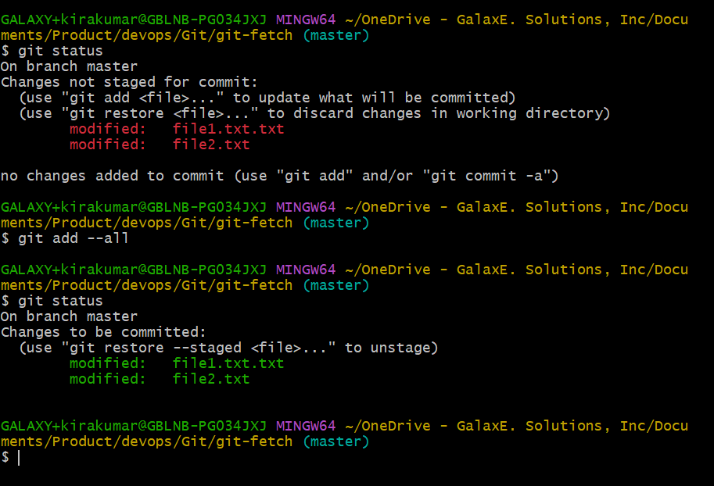

**-u or --update:** It is used to stage changes to tracked files in the git repository. It does not allow new untracked files to the staging area.

Syntax**:** git add -u or git add --update

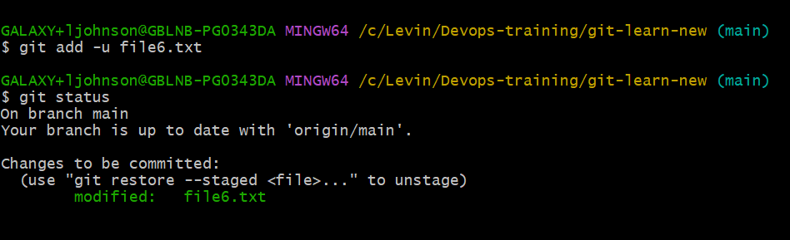

**-p or --patch:** Interactively adds changes to the staging area, allowing you to review and selectively add changes made to a file.

Syntax: git add -p <filename>

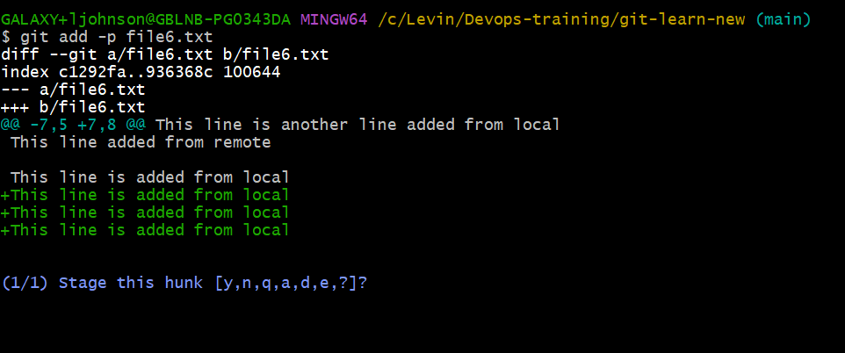

* **git commit:** This command is used to save changes to Git repository. When you run this command, Git creates a new commit object that contains the snapshot of the changes you have made to your files, along with the message describing the changes. It commits the code from the staging area to the local repository.

Syntax: git commit -m “message”

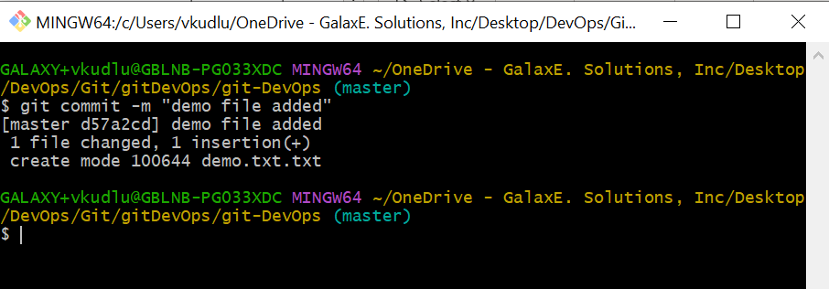

**Alternative way of git commit**

**git commit -a -m “commit-message”** – This command is used to directly commit into the local repository from the workspace without making use of staging area. git add command is basically skipped using this command. This command is basically used when small number of changes are edited in the workspace, and you want to directly commit it from the workspace without committing it from the staging area.

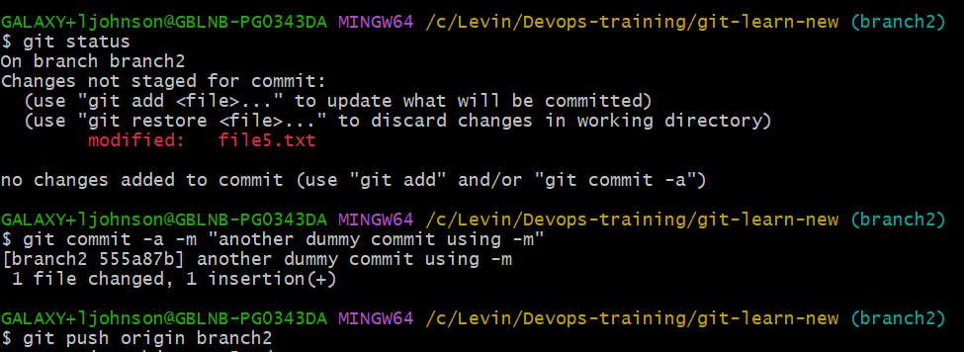

* **git restore:** This will restore the specified file to its state in the most recent commit. If the changes are staged, then restore does not work. If the changes are not staged, then restore command deletes all the modification done to that file.

Syntax: git restore <filename>

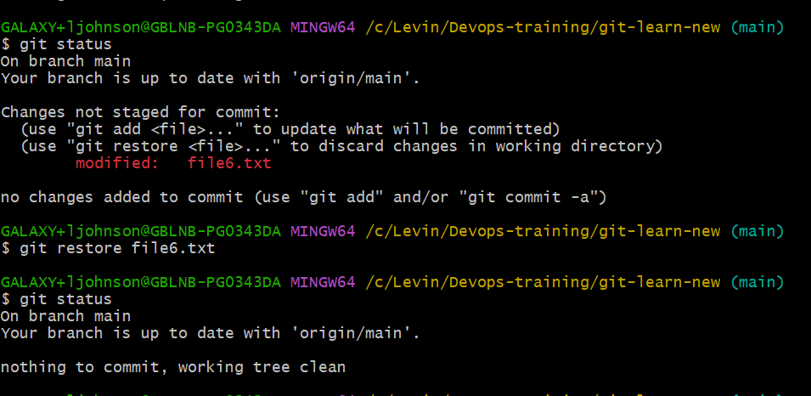

* **git rm filename:** It is used to remove files.

Syntax: git rm <filename>

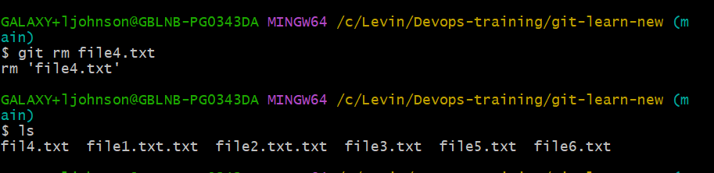

**Options**

**-r:** Allow recursive removal when a leading directory name is given.

Syntax: git rm -r <filename>

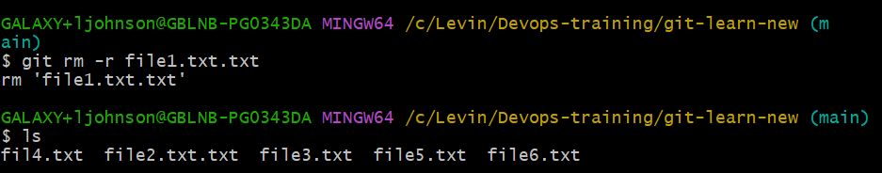

**-f:** Override the up-to-date check or to delete forcefully.

Syntax: git rm -f <filename>

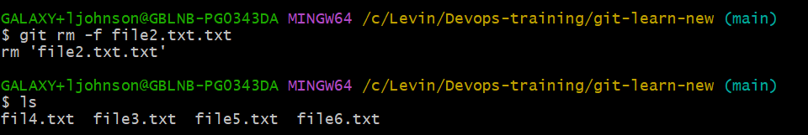

* 1. BRANCHING AND MERGING
* **git branch:** It is a git command which is used to list, create, or delete branches in git repository.

**To create branch**

Syntax: git branch <branchname>

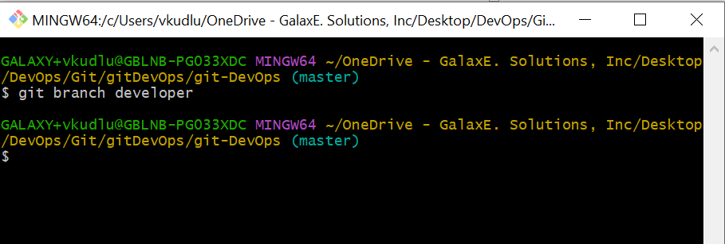

**To display branch**

Syntax: git branch <branchname>

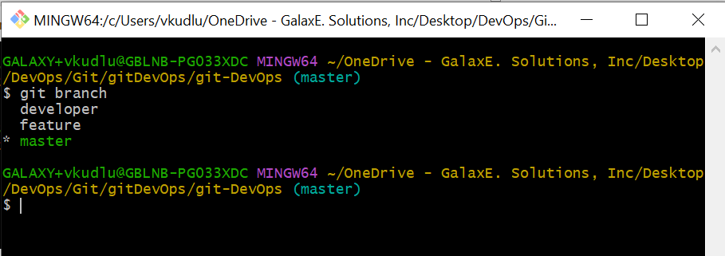

**Options**

**-a:** displays the list of all local and remote branches.

Syntax: git branch -a

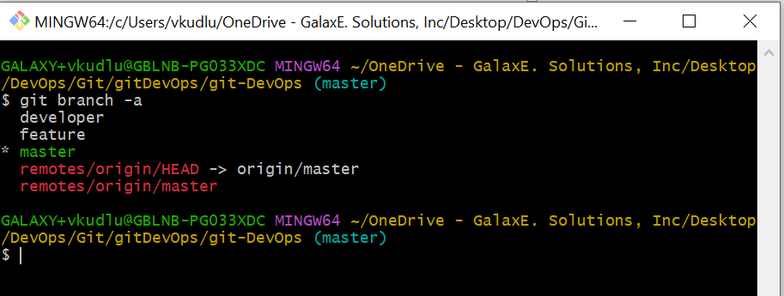

**-d <branchName>:** To delete a particular branch in local.

Syntax: git branch -d <branchname>

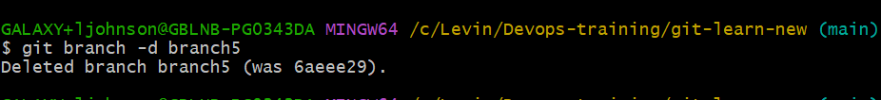

**To delete branch in remote**

Syntax: git push origin –delete branchname

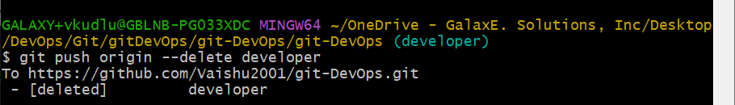

**-m <oldbranchname> <newbranchname>:** This command is used to rename branch in local.

Syntax: git branch -m <oldbranchname> <newbranchname>

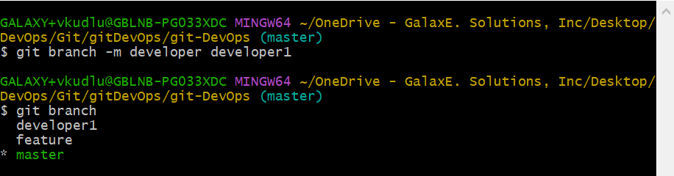

**To rename branch in remote**

Syntax:git push origin: <oldbranchname> <newbranchname>

**-r:** To display remote branches

Syntax: git branch -r

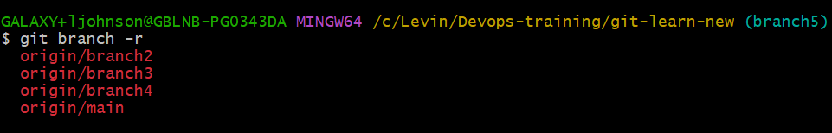

* **git checkout:** This command is used to switch between different branches.

Syntax: git checkout branchName

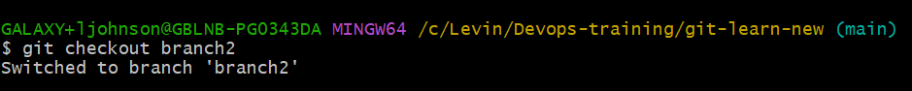

**Options**

**-b <newbranch>:** This command is used to create a new branch and switch to that branch.

Syntax: git checkout -b <newbranchname>



**<commit_id>:** This command is used to switch to a specified commit in Git. In this command Git updates the files in your working directory to match the state of the specific commit. However, you will be in a detached head state, meaning any changes you make will not be part of any branch.

Syntax: git checkout <commitid>

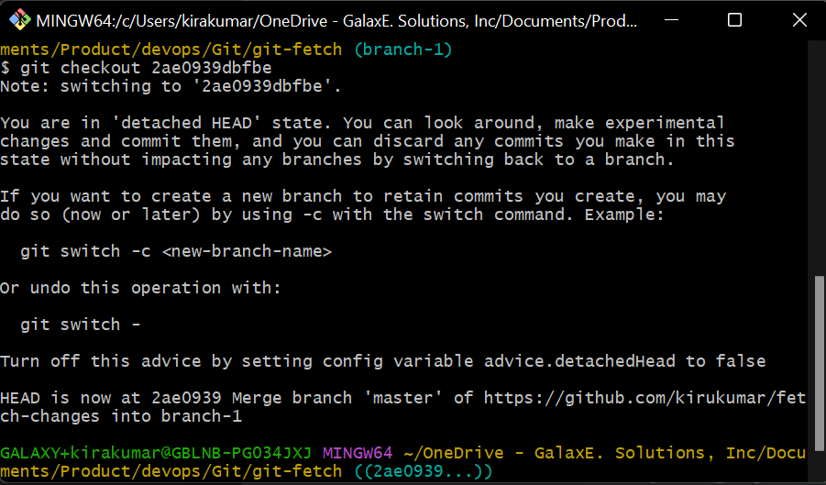

* **git merge:** This command is used to combine two or more branches into a single branch. When you are merging, Git will create a new commit that combines the changes from both the branches.

Syntax: git merge branchname (merging a local branch into main branch)

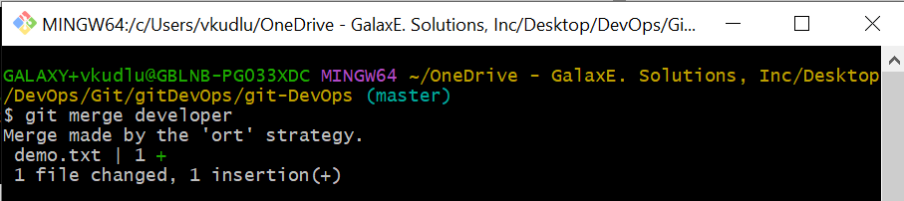

Syntax: git merge origin/<remotebranchname> (merging a remote branch on to a main branch)

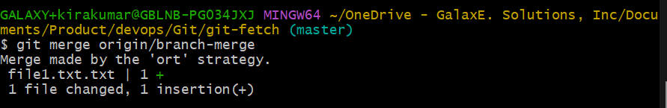

**Note**: After successful merge use git push to push the changes to the remote repositories.

**Merge Scenarios**

**Scenario1:** Merge local branch with the main branch.

**Step1:** Cloning a remote repository into your local machine.

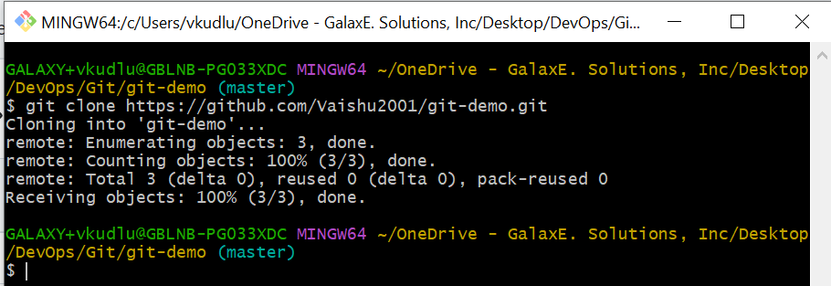

**Step2**: move to that directory which is cloned.

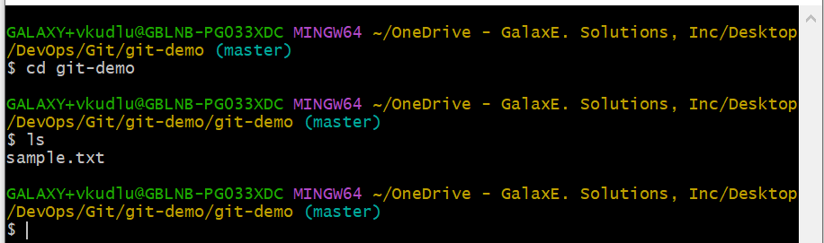

**Step3:** create new branch and modify changes in that branch.

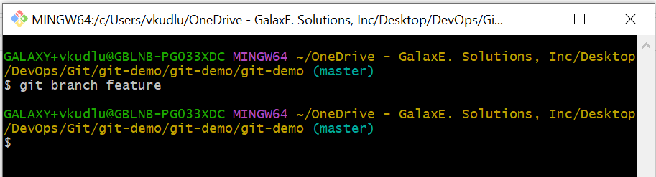

Here in this example a new file sample1.txt is created in the feature branch which is not present in main branch.

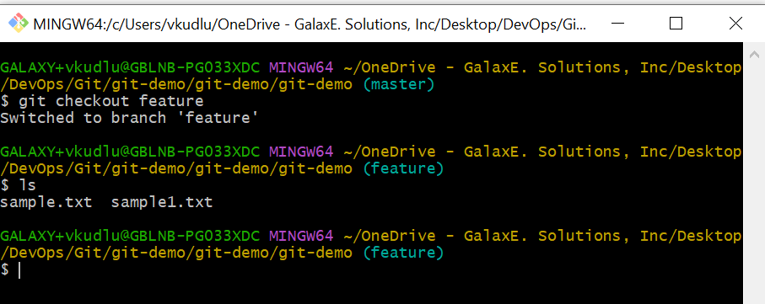

**Step4**: Add and commit the changes

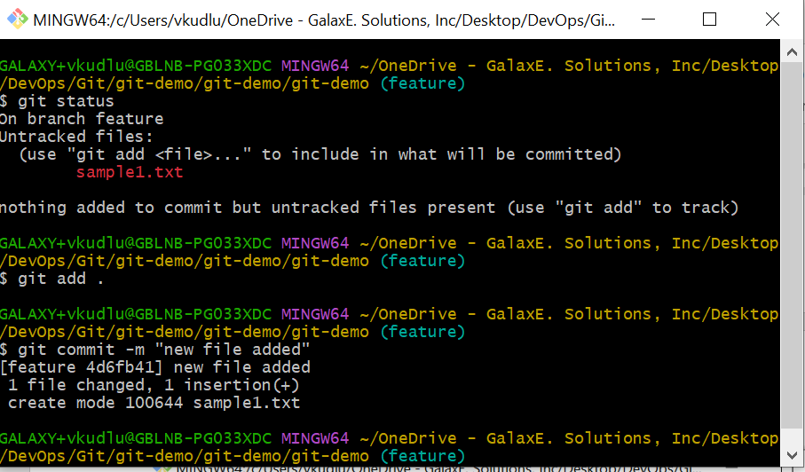

**Step5**: Checkout to that main branch and use merge command fro the branch to be merged.

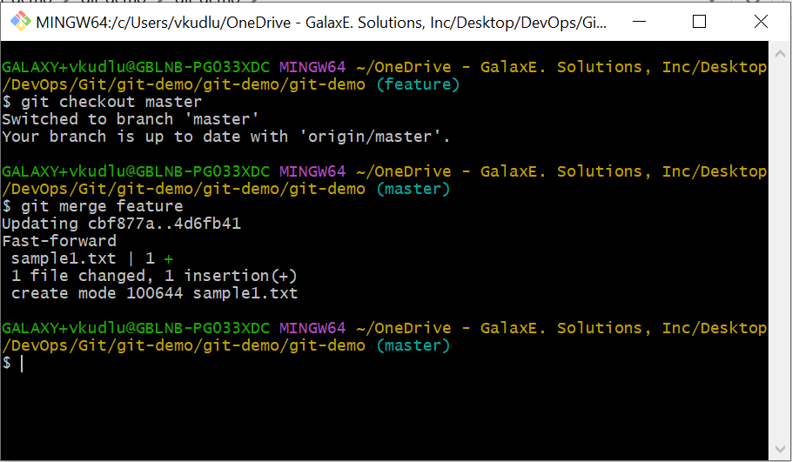

The below operation also resembles to a merge operation but with pull command.

**Scenario2:** Merge remote branch with local branch while pulling changes from the remote branch. This Operation is similar to merge operation.

If the remote branch has changes made by other developers and your local branch has commits done by you, so when you try to pull changes from the remote branch you will face merge request.

**Step1**: Fetch the changes from the remote repositories.

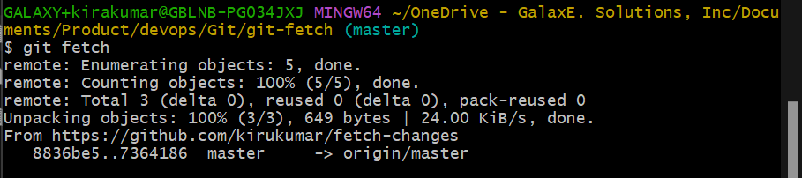

**Step2:** Pull changes from the remote repository by using command git pull origin branchName. An editor will open to enter the commit message.

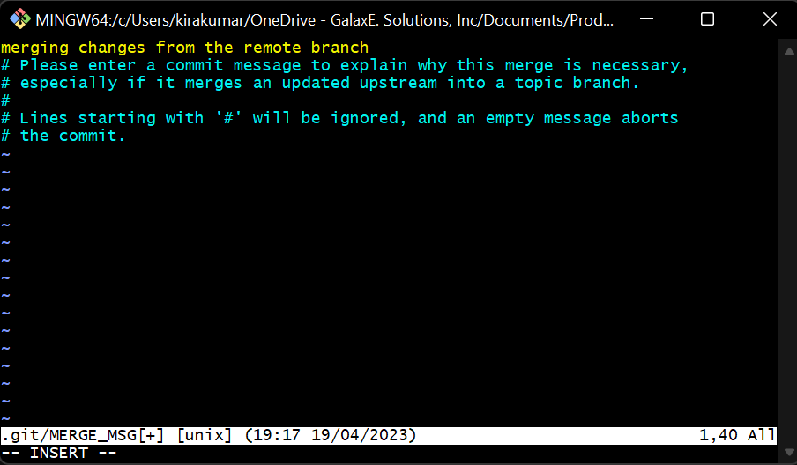

**Step3**: Pull request is completed successfully.

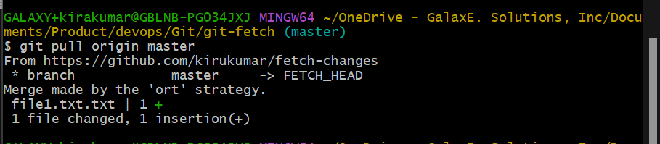

**Scenario3:** Merge remote branches with local main branch by using merge command.

**Step1**: Use fetch command to get the changes made in the remote.

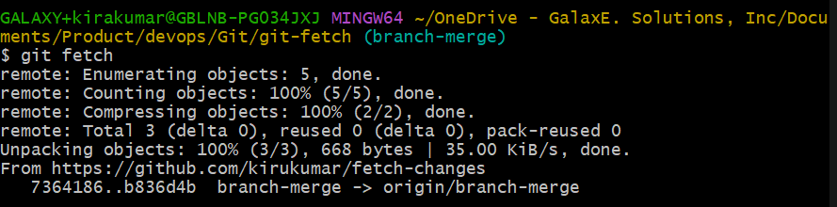

**Step2**: Checkout to that master branch where the remote branch has to merged and use the merge command.



**GIT MERGE CONFLICTS**

A merge conflict is an event that takes place when Git is unable to automatically resolve differences in code between two commits. Git can merge the changes automatically only if the commits are on different lines or branches.

Let’s assume there are two developers: Developer A and Developer B. Both of them pull the same code file from the remote repository and try to make various amendments in that file. After making the changes, Developer A pushes the file back to the remote repository from his local repository. Now, when Developer B tries to push that file after making the changes from his end, he is unable to do so, as the file has already been changed in the remote repository.

To abort merge, use command **git merge - -abort**

**TO OVERCOME MERGE CONFLICTS:**

**git mergetool** – it is used to display the merge conflict file, then we can edit the file using editor.

**To configure merge tool**

git config - -global merge.tool vimdiff

**To use vimdiff mergetool use command** - git mergetool

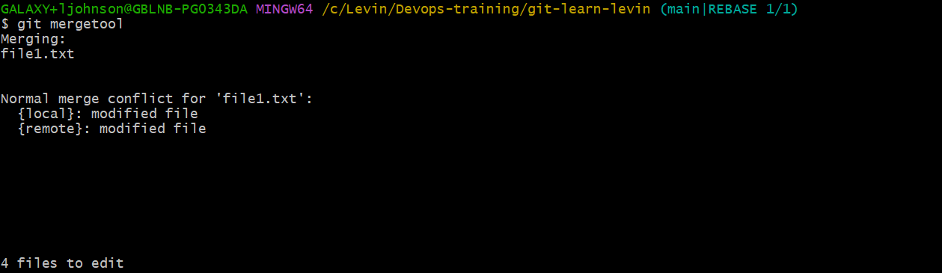

resolve merge and type :qa to exit and press enter and then commit with the message.

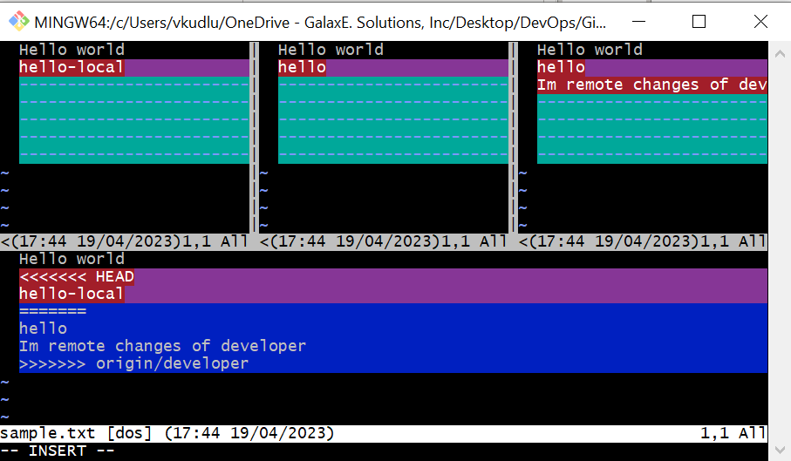

* **git log:** This command is used to display the commit history of a Git repository. It shows a list of commits, with the most recent commit appearing at the top of the list. By default, git log will the display information such as Hash, Author, Date, Commit message.

Syntax: git log

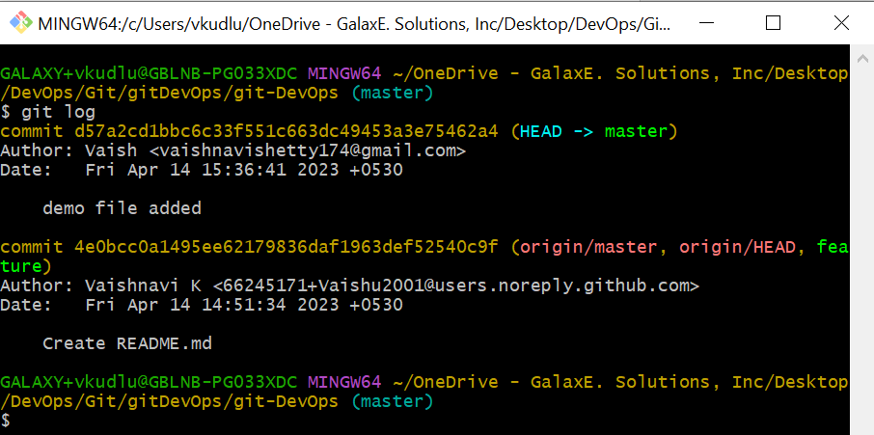

**Options**

**--oneline:** Displays log details in oneline format.

Syntax: git log --oneline

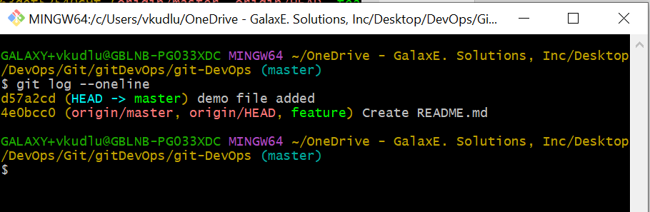

**--graph:** Shows the commit history as a graph.

Syntax: git log --graph

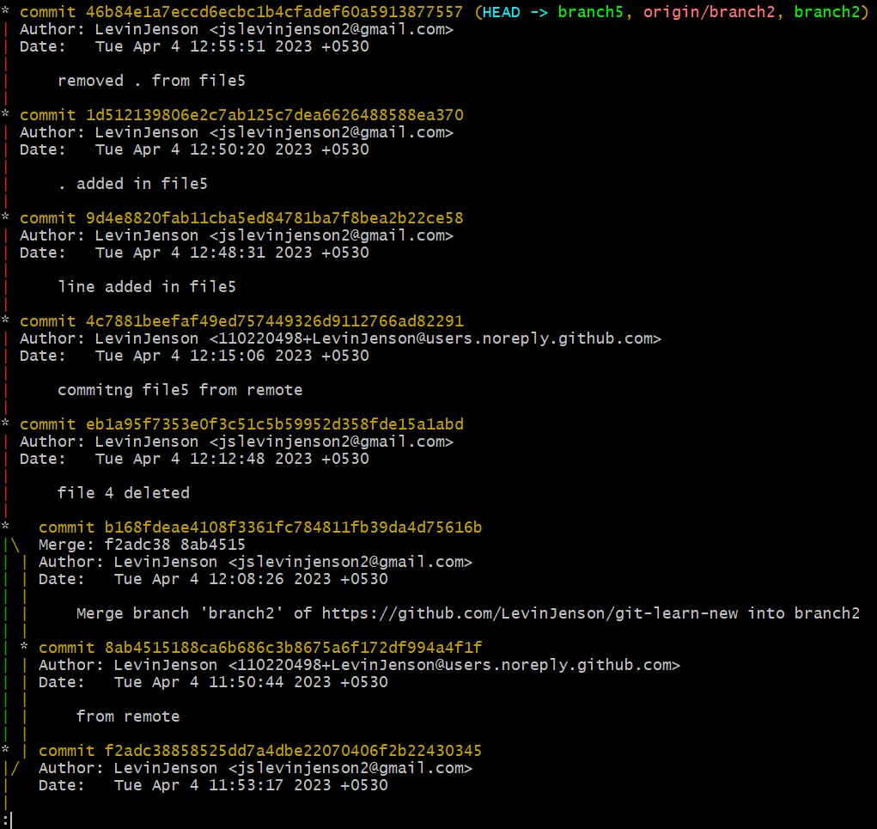

**--stat:** It will show detailed information about the changes made in each commit.

Syntax: git log --stat

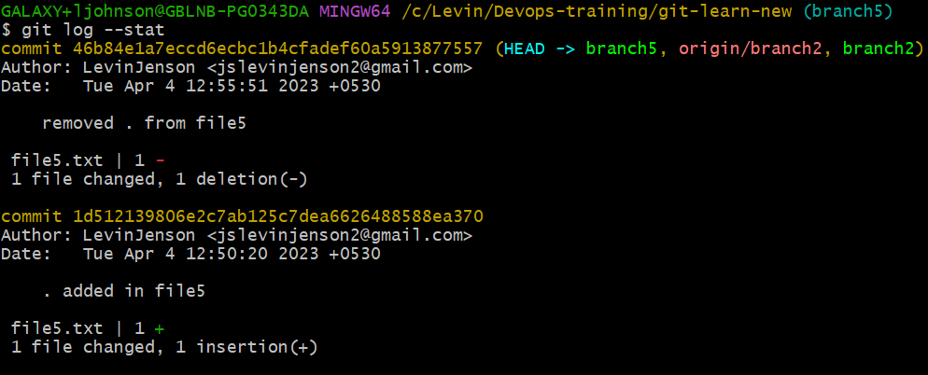

**--reverse:** It will show the commit history in reverse order.

Syntax: git log --reverse

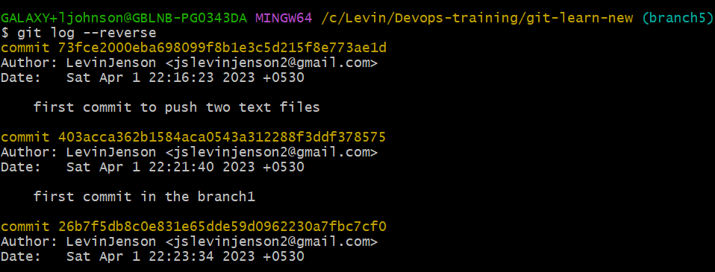

* **git stash:** This command is used to temporarily save changes that are not yet ready to be committed to the repository. When you run this command, Git will store your changes in a stash a temporary location in the repository were you can retrieve them later. Stash is stored as a commit sha and can be viewed in./logs/refs/stash./refs/stash.

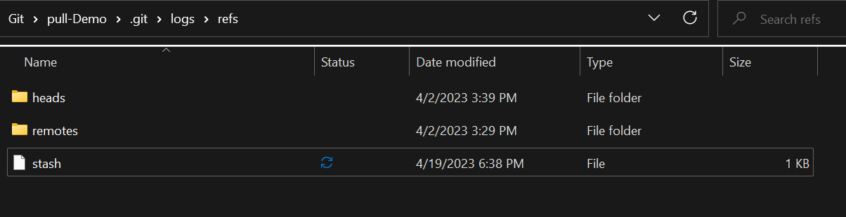

Syntax: git stash

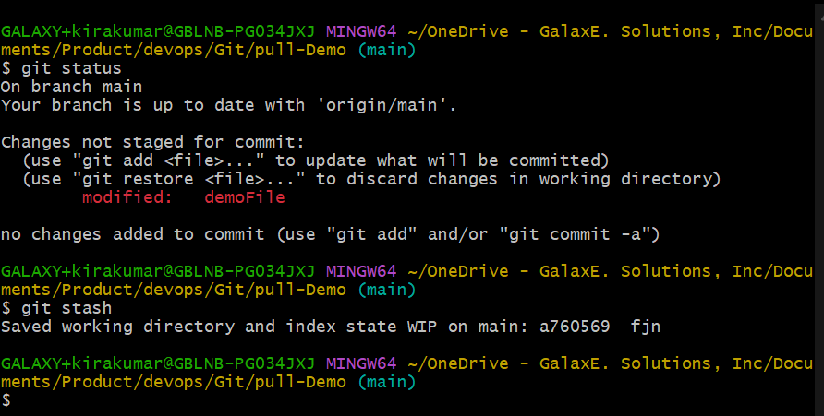

**To view stashed list**

Syntax: git stash list



**To re-apply the stashed changes**

Syntax**:** Git stash apply or git stash pop

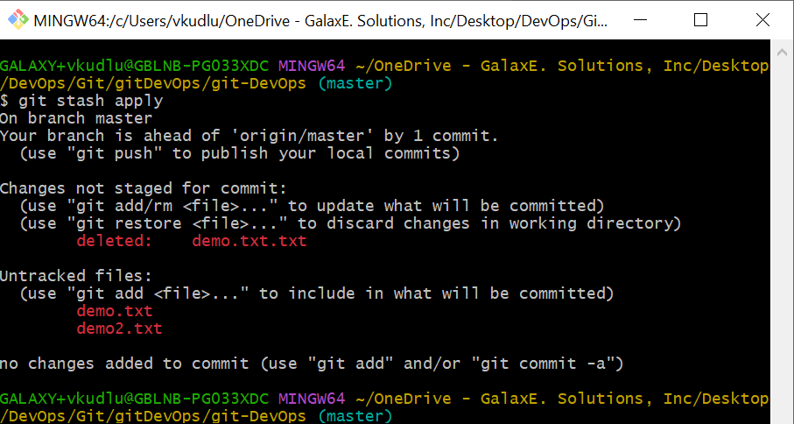

* **git tag:** This command allows you to create, list, delete, and manage tags. Tags are used in git to mark specific points in the history of a repository, such as releases or significant commits, for easy reference.

**To apply tag to last commit**

Syntax: git tag <tagName>

Ex: git tag v1.0

**To apply tag to particular commit id**

Syntax: git tag <tagName> <commitId>

Ex: git tag v1.0 ae321970

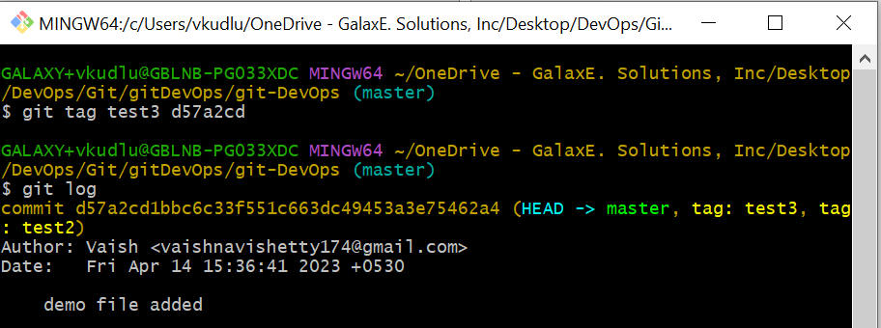

**Options**

**-a:** This option is used to create an annotated tag. An annotated tag includes a message that describes the tag, which can be useful for others who view the tag.

Syntax: git tag -a <tagname> -m “tagmessage”

Ex: git tag -a v1.0 -m “new version release”





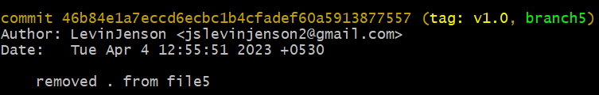

**git push --tags:** is to push local created tags into remote repositories.

**git tag -f <tag>:** -f option is used to force the creation of a tag, even if a tag with the same name already exists.



5.5 SHARING AND UPDATING PROJECTS

* **git fetch**- This command is used to retrieve the latest changes from a remote Git repository, without merging them into your local branch. When you run this command, Git will download any new changes from the remote repository, but will not make any changes to your local branch.

Syntax: git fetch-🡪This command fetches changes from all the branches.

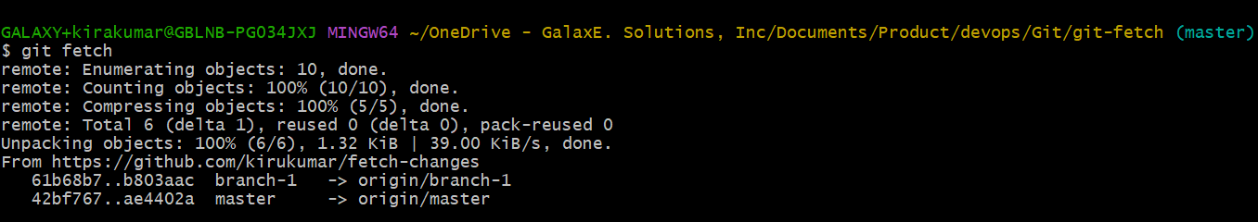

Syntax: git fetch origin master

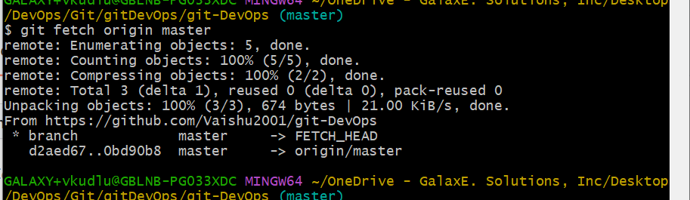

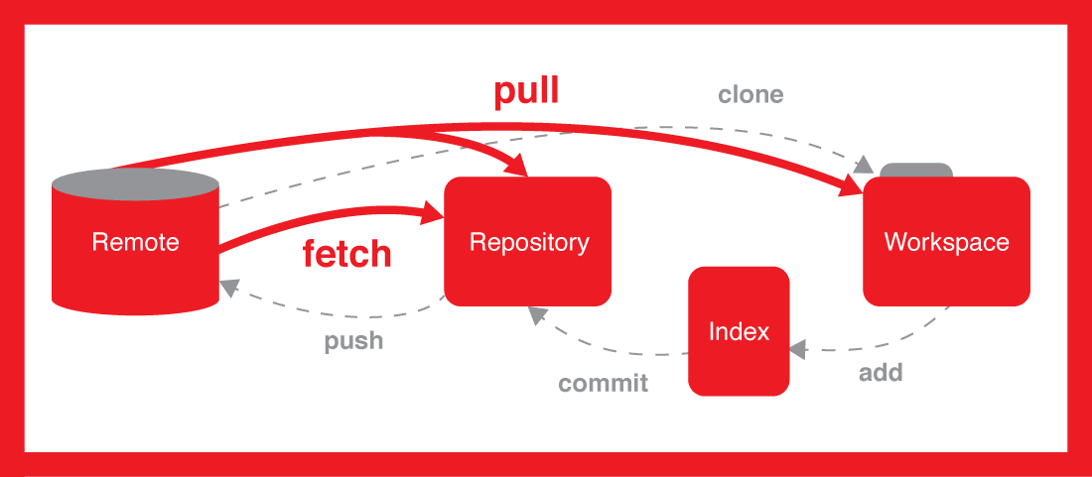

**Options**

**--all:** This command is used to fetch all changes from the remote repositories and update it to your local repository. It fetches changes from all branches.

Syntax**:** git fetch --all

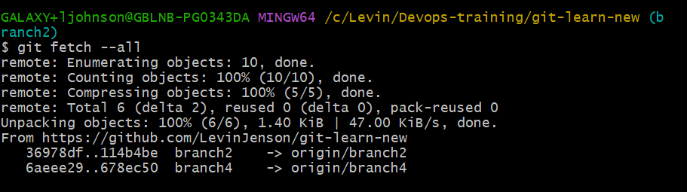

* **git Pull:** This command is used to retrieve the latest changes from the remote Git repository and merge them into your local branch. When you run this command, Git will first fetch the latest changes from the remote repository using the git fetch command, and then merge those changes into your local branch.

**Syntax:** git pull -🡪 This command will pull the latest changes from the remote for the current branch.

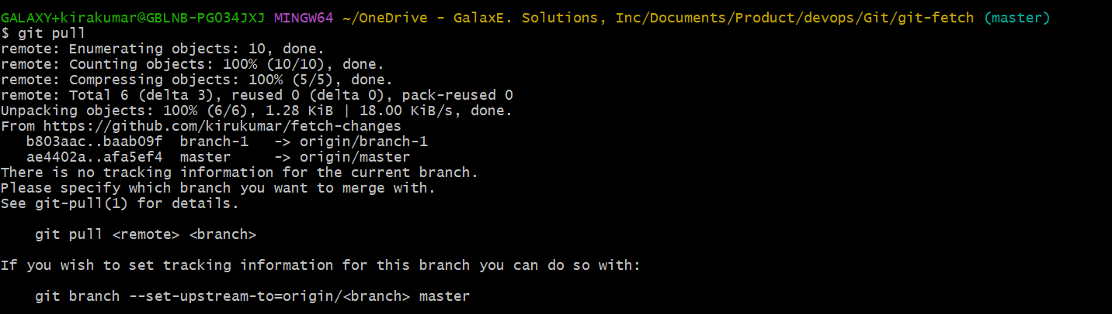

**To pull changes from remote master branch**

Syntax: git pull origin master

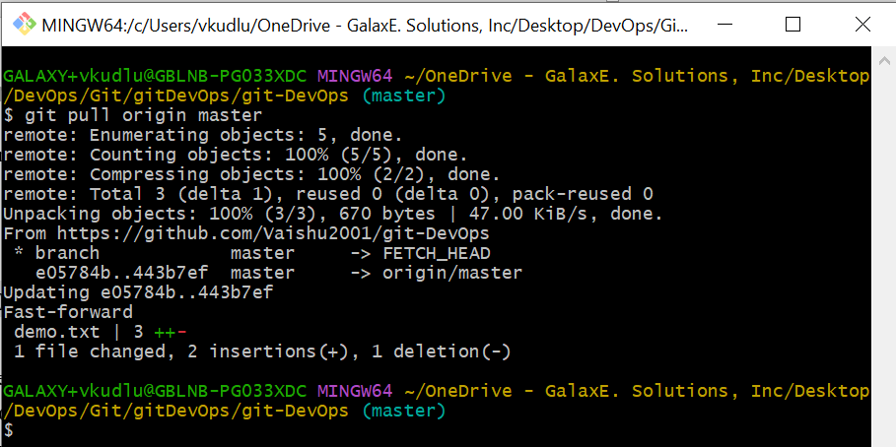

**To pull changes from remote different branch**

Syntax: git pull origin <branchname>

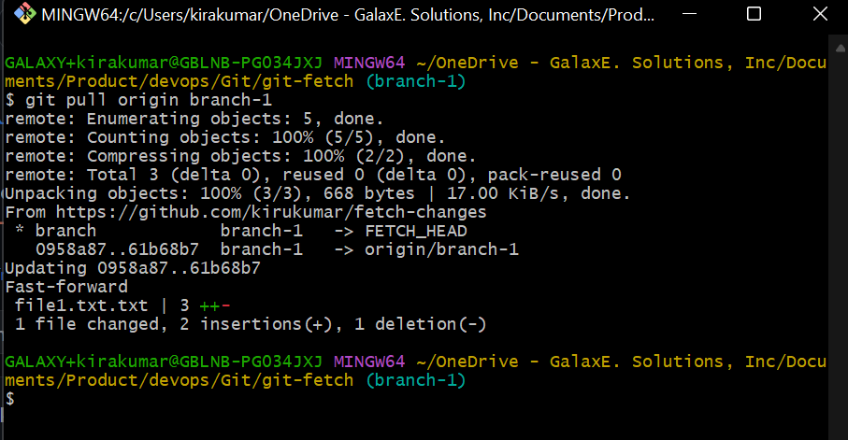

**Options**

**-q or --quiet:** The -q option stands for "quiet" and is used to make git pull run silently, without printing any output to the console except for error messages.

Syntax: git pull -q origin <branchname>

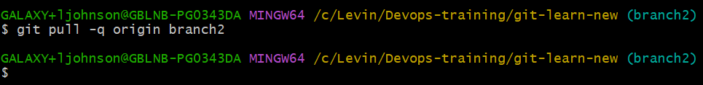

* **git push**: This command is used to update your local changes to a remote repository. When you run this command, Git will upload the local git commit changes from your local branch to the specified remote repository.

Syntax: git push -🡪 This command is used to push the changes from the local branch to the current remote branch.

Syntax: git push origin <branchname>

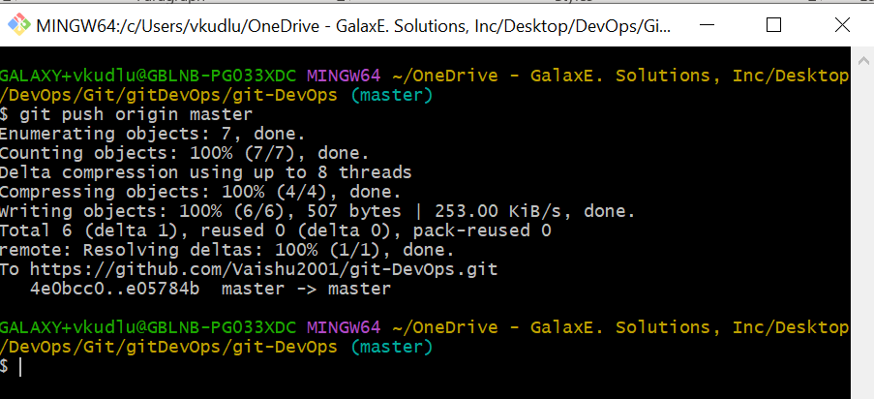

**Options**

**--all:** This command is used to push all locally created branches into remote repository. This means that any changes made to any of the local branches will be pushed to remote repositories.

Syntax**:** git push --all

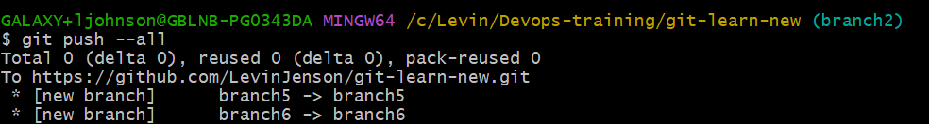

**--tags:** This command is used to push all the tags to the remote repository.

Syntax**:** git push --tags

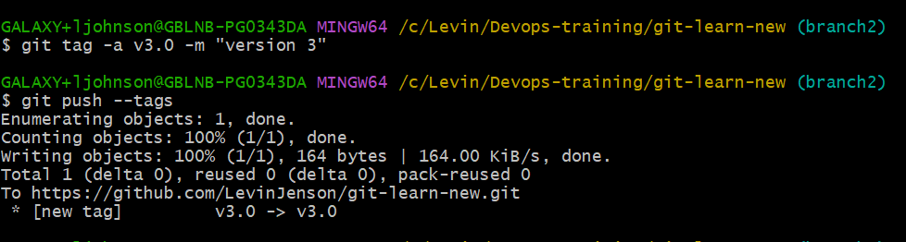

5.6 INSPECTION AND COMPARISION

* **git show**: The git show command is used to display various types of objects in Git such as commits, tags, and trees.

**To view branch details**

Syntax: git show <branchname>

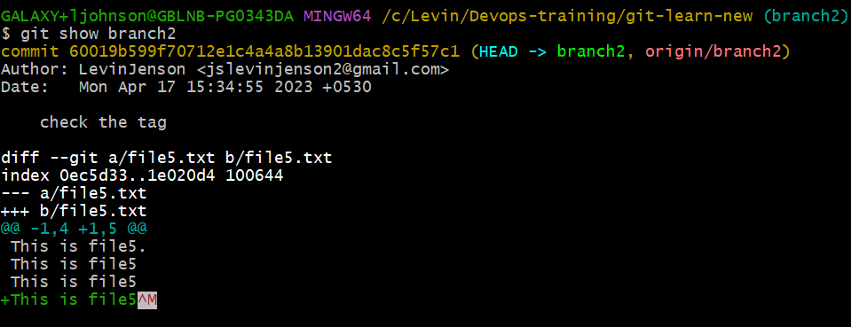

**To view commit details**

Syntax: git show <commitid>

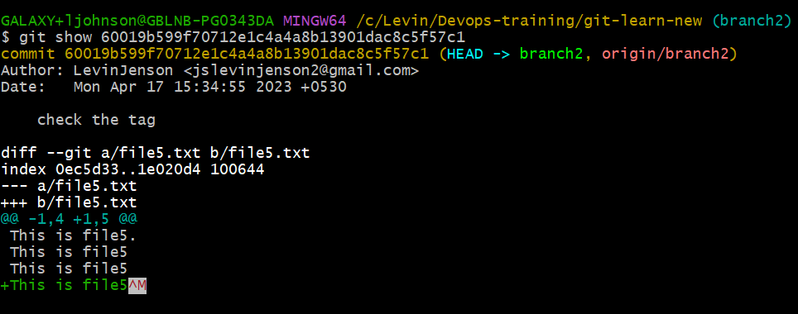

**To view tag details**

Syntax: git show <tagName>

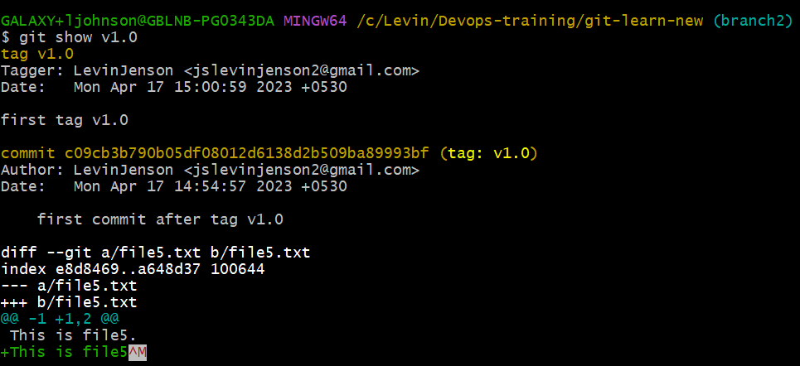

5.7 PATCHING

* **git diff** -it is used to compare files or commit id or one commit id or one file.

Syntax: git diff <commit_id1> <commit_id2>

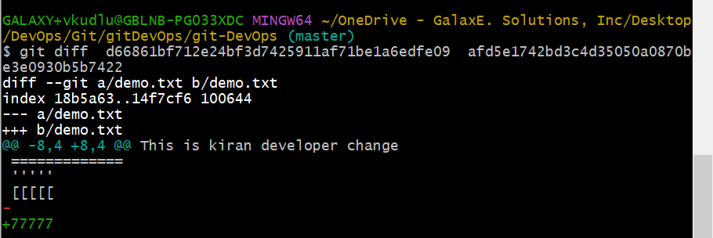

Syntax: git diff <filename1 ><filename2>

Syntax: git diff <localBranch> <remoteBranch>

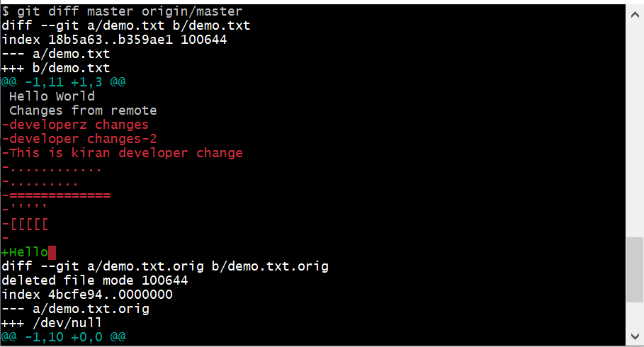

**To use git diff with single file**

**git diff <filename>** – It shows the changes made in the particular file (comparing both local and remote repository)

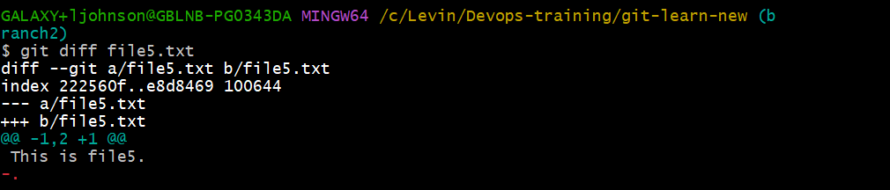

**Options**

**--no-index:** Allows you to compare two files or directories that are not in a Git repository. This can be useful, for example, when you want to compare two different versions of a file or directory that are not currently tracked by Git. To compare two files that are not present in git repository.

Syntax: git diff --no-index <filename1> <filename2>

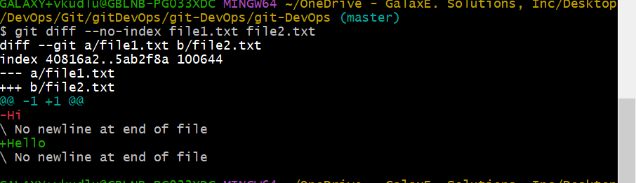

**--shortstat:** When used with the **--shortstat** option, **git diff** displays a single line of output that summarizes the changes in terms of the number of files changed, the number of lines added and deleted, and the total size of the changes.

Syntax: git diff –shortstat <filename1> <filename2>

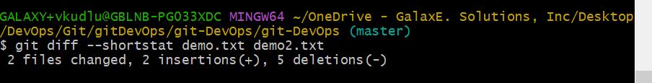

**--name-status:** This option shows the names and status of the files that have changed (added, modified, or deleted).

Syntax: git diff --name-status <filename1> <filename2>

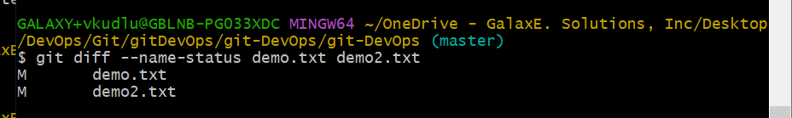

* **git rebase:** This command is used to update a branch in Git repository by applying the changes from another branch on top of the current branch. This can be useful for keeping a branch up to date with changes made in another branch or for reorganizing the commit history of a branch.

Syntax: git rebase <branchname>



**REBASE VS MERGE**

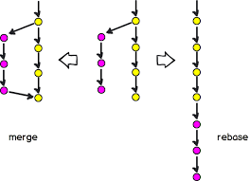

Git rebase is a command that lets users integrate changes from one branch to another, and the logs are modified once the action is complete. Git rebase was developed to overcome merging’s shortcomings, specifically regarding logs.

**Options**

**--continue:** The "git rebase --continue" command is used to continue a rebase operation after resolving a conflict.

**--abort:** When you perform a Git rebase operation, Git will try to apply the changes from your current branch onto another branch. If there are conflicts during the rebase process or if you want to stop the rebase for any other reason, you can use the "git rebase --abort" command to abort the rebase operation.

Syntax: git rebase --abort

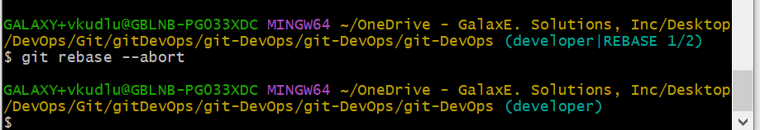

**--skip:** If you want to skip a commit during a rebase, you can use the **--skip** option. This will tell Git to skip the current commit and move on to the next one.

Syntax: git rebase –skip

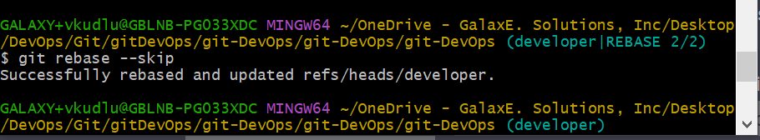

* **git revert:** This is a git command which allows you to undo the previous commit by creating a new commit that contains the opposite changes. It’s a way to safely undo changes without losing any of the commit history.

Syntax: git revert <commitid>

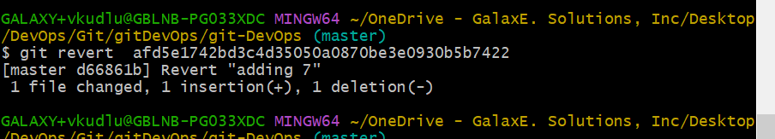

**Options**

**--no-commit**: This option tells Git to revert the changes but not to create a new commit. This can be useful if you want to make additional changes to the reverted files before committing them.

Syntax: git revert --no-commit <commitid>

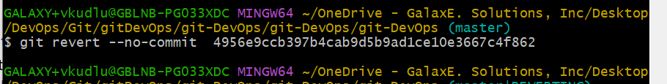

**--no-edit**: This option tells Git to create a new commit that undoes the changes made by the original commit without opening the default commit message editor. This can be useful if you just want to create a new commit quickly without modifying the commit message.

Syntax: git revert --no-edit

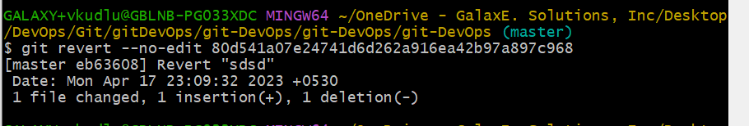

* **git reset**- Whenever the changes are in staging area git reset is used to discard the changes in it.

Syntax: git reset

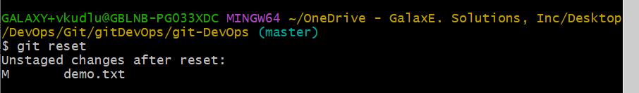

**Options**

**--hard:** This command will reset the branch pointer, the staging area, and the working directory to the specified commit. This is a destructive operation that will discard any changes you have made since the specified commit.

Syntax: git reset –hard

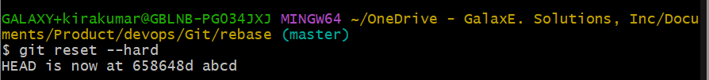

**--merge:** This command is used to undo a merge. It resets the branch to the specified commit and resets the index and working tree to the state before the merge.

**--hard<commit>:** This option is similar to –hard, but it allows you to specify the commit to reset to directly, rather than using a relative reference like HEAD~1

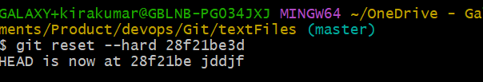

5.8 OTHER COMMANDS IN GIT BASH

* **To check the username of the currently logged user**

Syntax: whoami

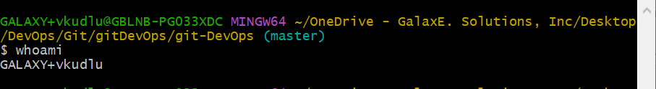

* **To check the path of the working directory**

Syntax: pwd

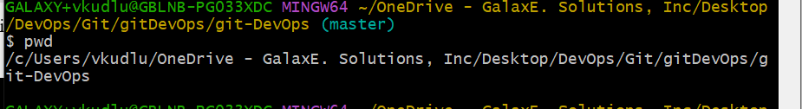

* **To view detailed information under that directory**

Syntax: ls -l

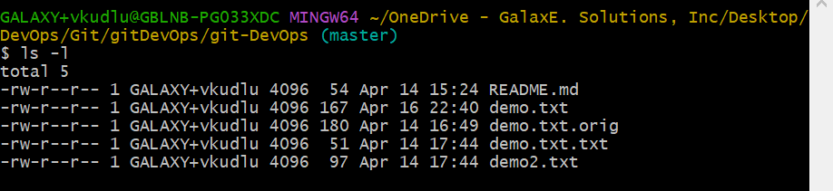

* **To view files or items under that directory without detailed information**

Syntax: ls -f

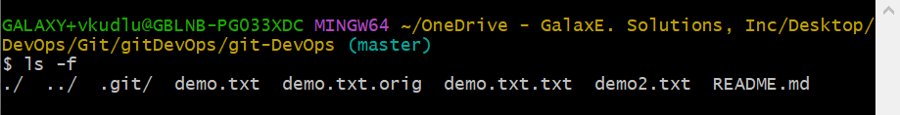

* **git-help:** This command gives the detailed information of all the commands in git usage.

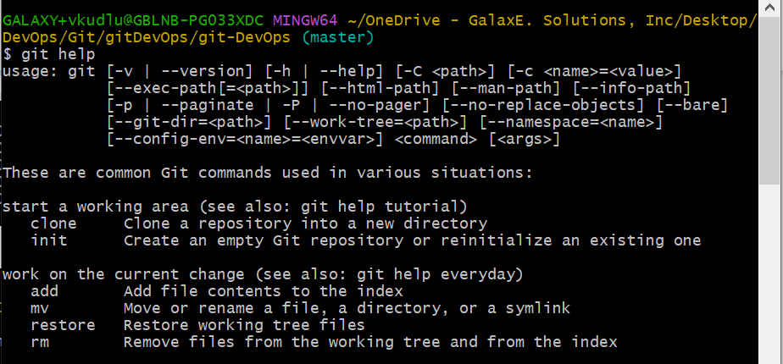

* **To check to which remote repository we are connected.**

Syntax: git remote -v

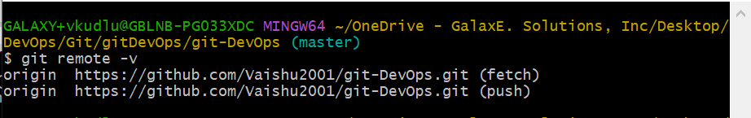

* **To rename remote repositories**

Syntax: git remote rename <previous-remote-name> <new-remote-name>

Ex: git remote rename origin repo1

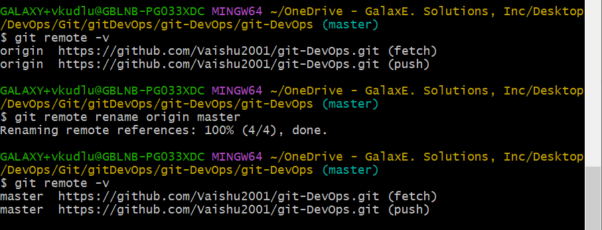

* **To remove repository connection**

Syntax: git remote remove <reponame>

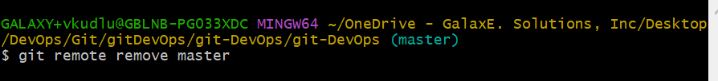

6. GITHUB

GitHub is a Git repository hosting service. GitHub also facilitates with many of its features, such as access control and collaboration. It provides a Web-based graphical interface.

It hosts source code of your project in the form of different programming languages and keeps track of the various changes made by programmers.

It offers both **distributed version control and source code management (SCM)** functionality of Git. It also facilitates with some collaboration features such as bug tracking, feature requests, and task management for every project.

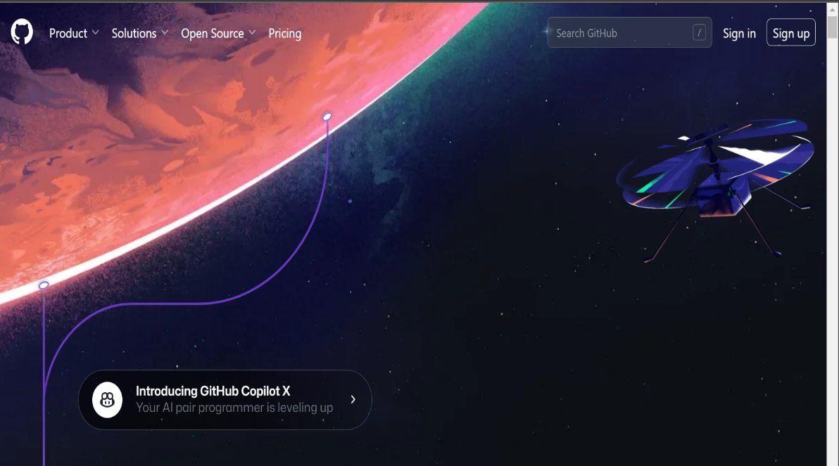

7. FORK IN GITHUB

Fork is used to copy some existing repository (you create copy of original repo) so that you can start contributing into it.

Use case: To fix bugs or issues.

* **Step 1: Fork a Repository**: Again, the user starts from the upstream repository on GitHub, but this process starts from forking when they fork a repository to their own GitHub account.

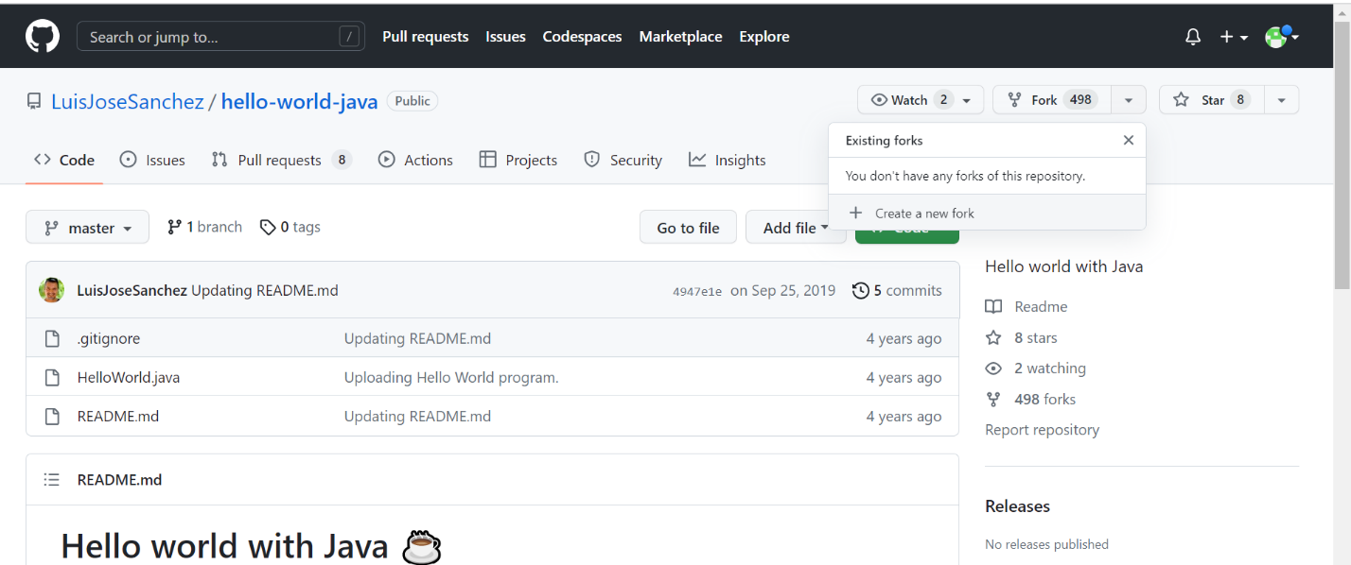

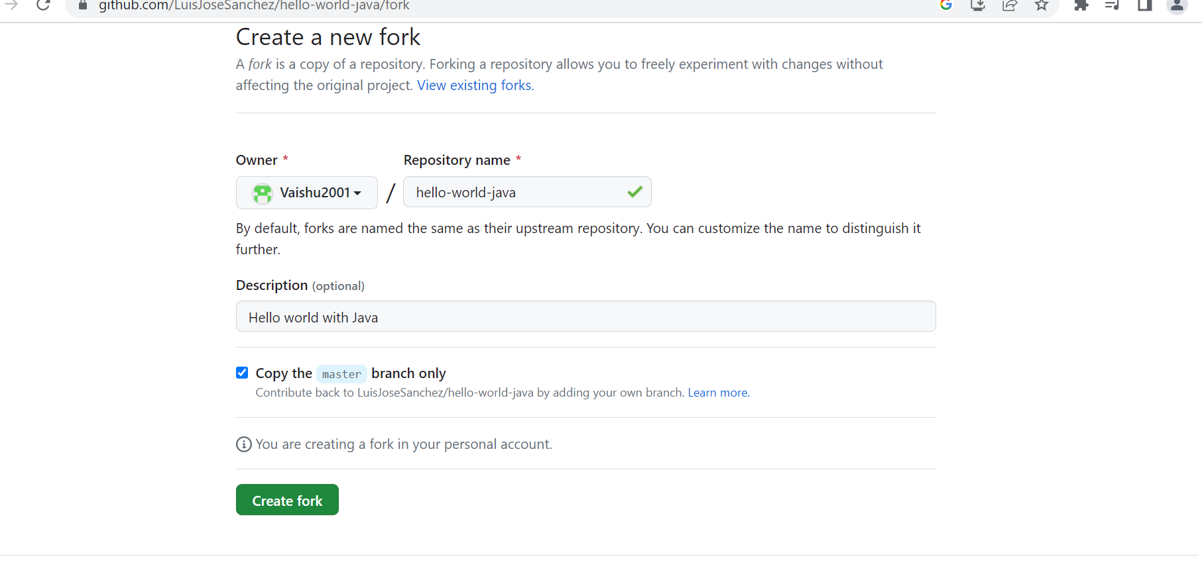

Once the repository is forked the owner account will be changed to your username and the copy of the repository will be in your repository list.

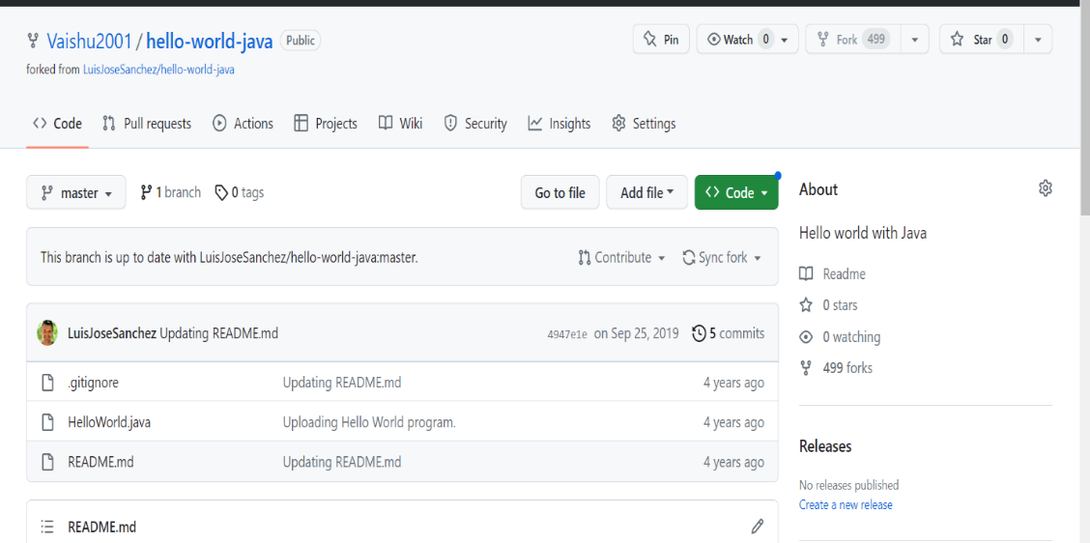

* **Step 2: Clone a Repository**: Same as cloning.

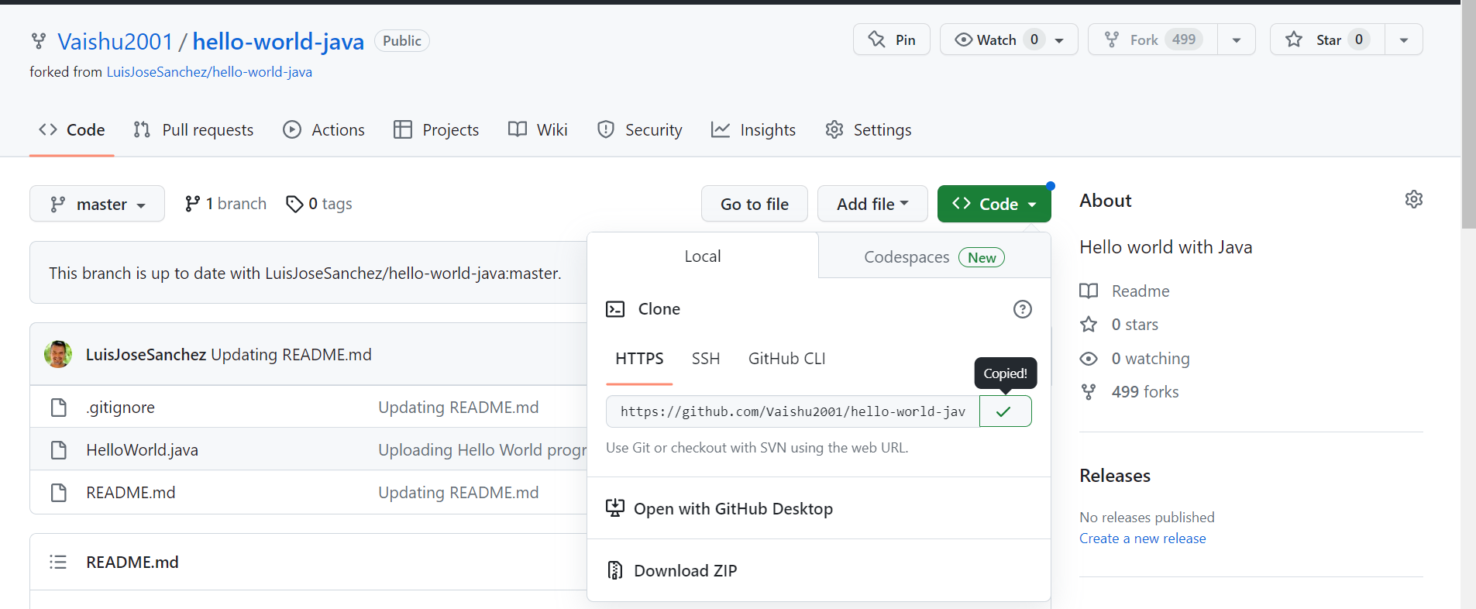

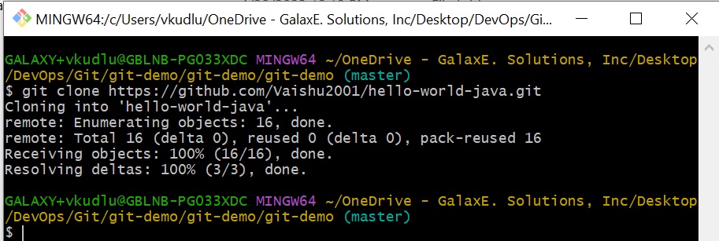

* **Step 3: Make the desired changes**: Same as cloning.

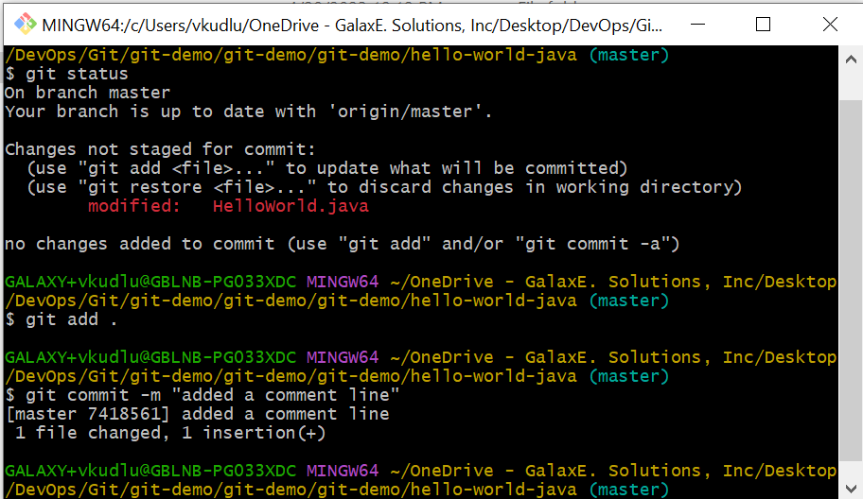

* **Step 4: Pushing the Changes**: Same as cloning.

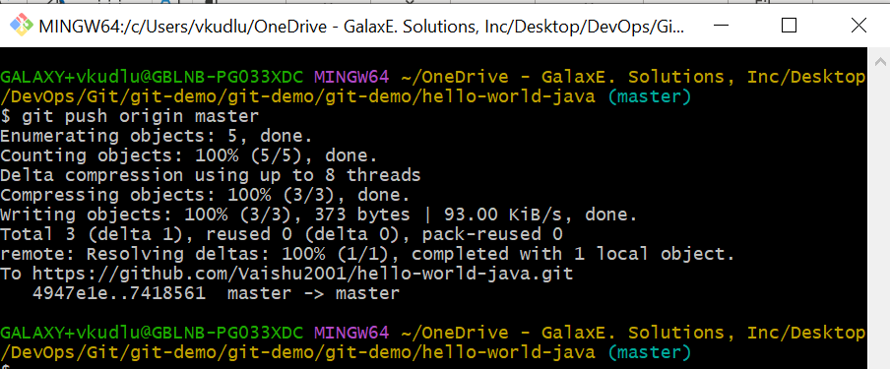

* **Step 5: Send changes to Original Repository**: This process is called **Pull Request** in Git. At this step, the user sends the changes to the owner of the repository as a request to merge the changes to the main central repository.

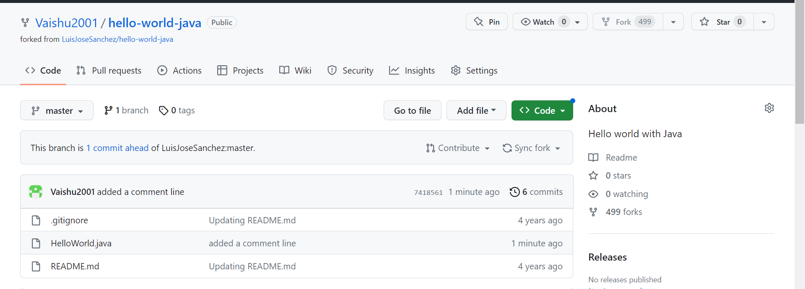

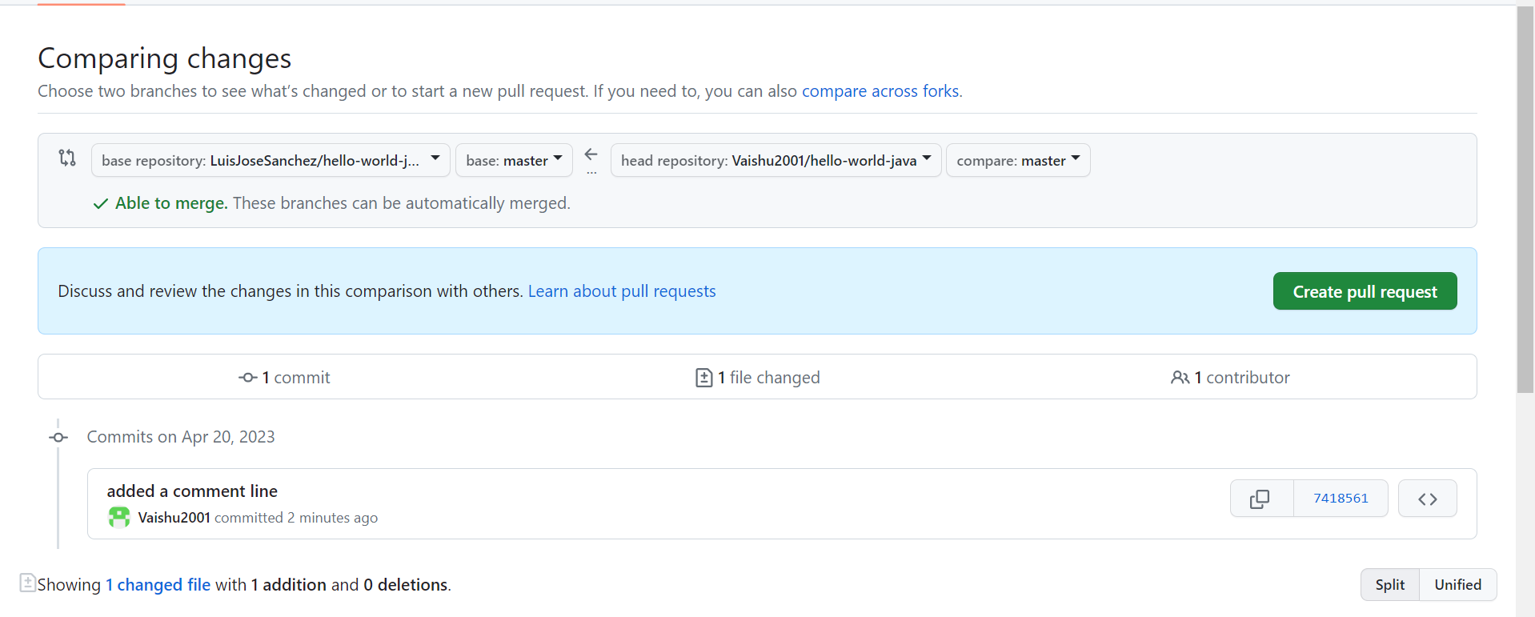

Sending request to the original repository owner to update the changes made by the forked user.

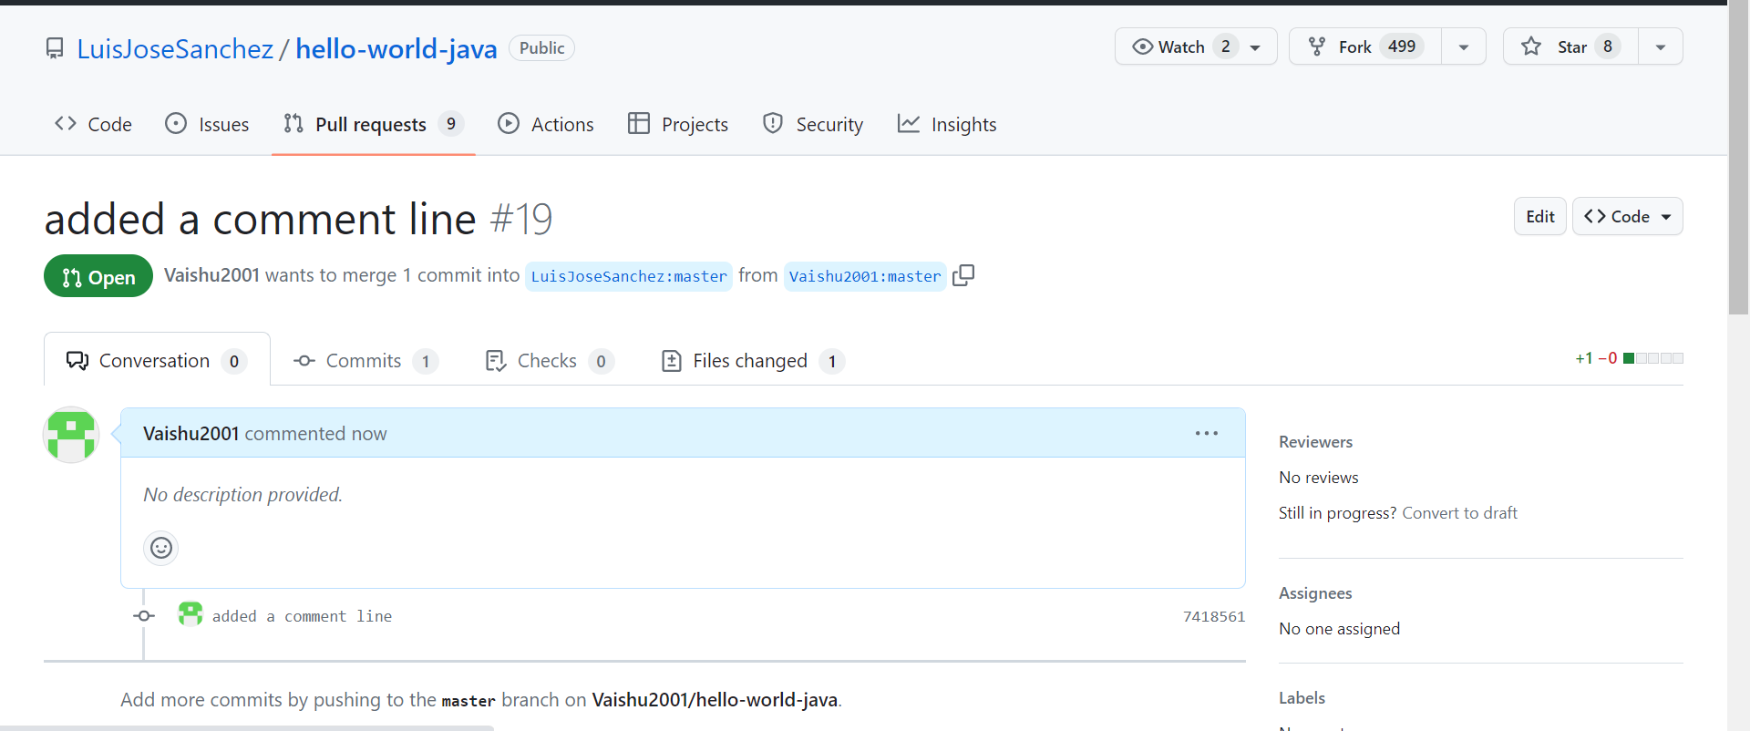

8. WEBHOOKS IN GITHUB

A Git webhook is a mechanism that allows Git repositories to send automatic notifications to other systems or services when certain events occur, such as when a new commit is pushed or a branch is updated. This enables continuous integration and delivery workflows by triggering automated processes such as builds, tests, and deployments.

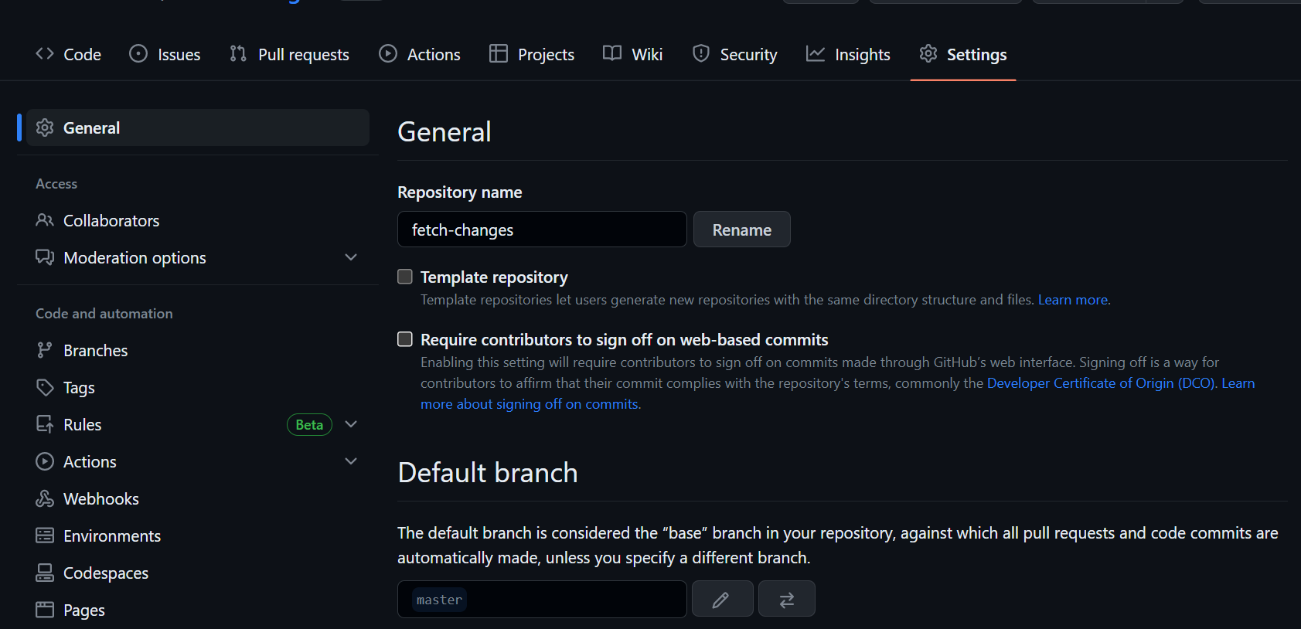

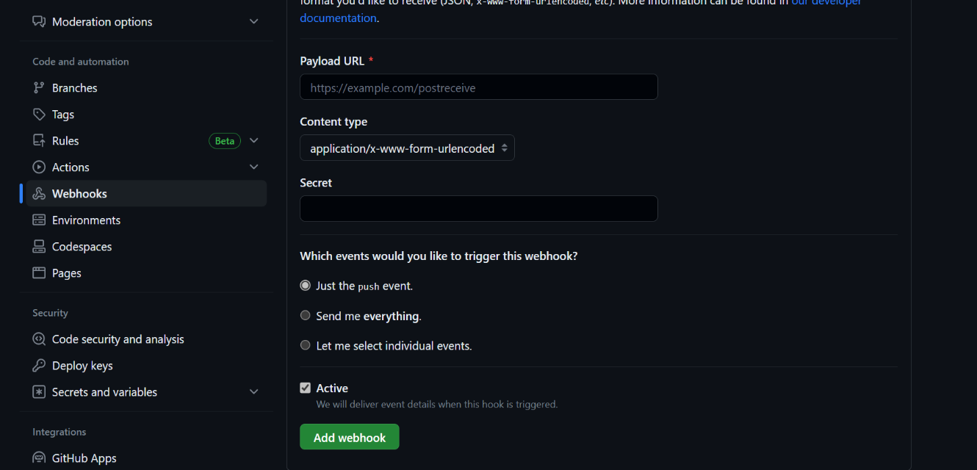

In the Payload Url upload the Jenkins url +/github-Webhook/

9. Document Revision History

|  |  |  |  |  |  |
| --- | --- | --- | --- | --- | --- |
| Date | Version | Created By | Reviewed By | Approved By | Description of change |
|  |  |  |  |  |  |
|  |  |  |  |  |  |
|  |  |  |  |  |  |
|  |  |  |  |  |  |
|  |  |  |  |  |  |